User Guide
Data Dictionary
Prepared by
Jaanus Heinlaid, TietoEnator
Enriko Käsper, TietoEnator
December 2004
Version 1.0
User Manual
Version management
No | Date | Changes | Author
0.1 | 18.02.02 | First draft, triggered by the publication of a major update at demo site | Jaanus Heinlaid
0.2 | 24.03.03 | Situation at demo site at the end of SA-5 | Enriko Käsper
0.3 | 08.04.03 | Some changes requested by project leader. The structure of the document was organized according to the each users needs. Chapter 1 added. | Enriko Käsper
0.4 | 08.09.03 | Updates related to the release of DD version 1.2test | Jaanus Heinlaid, Enriko Käsper
0.41 | 27.10.03 | Additions to cp 4.2.3: Recycle Bin for deleted datasets and Cp 4.4.9 Foreign Key relations | Jaanus Heinlaid, Enriko Käsper
0.42 | 07.11.03 | Additions & changes regarding developments since last updates | Jaanus Heinlaid, Enriko Käsper
0.43 | 21.11.03 | Documenting new features and bug fixes | Jaanus Heinlaid, Enriko Käsper
0.5 | 31.03.04 | Documenting new features | Jaanus Heinlaid
0.51 | 30.07.04 | Documenting new features | Jaanus Heinlaid
0.52 | 30.08.04  24.10.04 | Documenting new features | Jaanus Heinlaid
0.53 | 10.12.04 | Final reviewed draft for EEA’s comments approval | Heinlaid, Palosuo

Project manager: Eeva Palosuo
Contents
Foreword 5
1. Content & Concepts 6
1.1. Dataset definitions 6
1.2. Table definitions 6
1.3. Data element definitions 6
1.4. Attribute 8
1.5. Unique identification of datasets, tables & elements 9
1.6. User groups 10
1.7. Versioning of data definitions 11
1.8. Registration statuses 11
1.9. Working copies and definitions in work 12
2. Functionality overview 13
2.1. Opening view 13
2.2. All-users functionality 16
2.3. Data definers and administrators functionality 17
2.4. Administrators-only functionality 17
2.5. Online help 18
3. All-users functionality 18
3.1. Dataset definitions 18
3.2. Table definitions 22
3.3. Data element definitions 24
3.4. GIS tables and elements 29
4. Data definers & administrators functionality 30
4.1. Simultaneous editing- checking in & checking out (Or ‘Lock-for-editing & Release changes & Undo changes) 30
4.2. Versioning details 31
4.3. Dataset definitions 32
4.4. Table definitions 39
4.5. Data element definitions 45
4.6. Working with complex attributes 52
5. Administrators-only functionality 54
5.1. Defining attributes 54
5.2. The cleanup function 67
6. Import tool 69
6.1. Table structure 69
6.2. Insert data 74
6.3. Generate XML file 76
6.4. Importing the data into Data Dictionary 78
6.5. Import results 79
6.6. Importing fixed values only 80
6.7. Limitations 81

Foreword
This document presents the guidelines for usage of the Data Dictionary (DD) system developed under the IDA/EINRC framework contract No 501 998. Operational software is running at the European Environment’s site http://dd.eionet.europa.eu .
The document has 5 main chapters.
Chapter 1 starts off by describing the basic concepts and content of Data Dictionary that are absolutely essential for understanding the rest of the document. It includes definitions of the three main concepts (datasets, tables and data elements), definition of metadata needed to describe those concepts (attributes) and also the definition of main user groups in Data Dictionary and what is their relation to the application.
Chapter 2 makes an overview about all the functionality provided by Data Dictionary. While this is a general description of use cases and opening view, chapters 3 and 4 will go more into the details.
Chapter 3 is meant for all the Data Dictionary's user groups and mainly describes how to search, browse and view the DD content. In other words it covers the read-functions.
Chapter 4 is meant for the user group of data definers, i.e. those users who have the rights, knowledge and skills to define the data for data suppliers to report. So this chapter covers the write-functionality, as opposed to chapter 3. It includes functions to add, delete and update data definitions. You will find the descriptions of all such functions illustrated with screenshots. The chapter also includes the description of a helper tool, used for the data's initial upload- the so-called Import tool.
Finally, chapter 5 is meant for the user group of administrators, i.e. those who should have all imaginable permissions both on DD contents and application itself, including the permission to edit DD’s metadata which is mainly the dynamical attribute set used for creating data definitions.

Content & Concepts
Data Dictionary holds definitions of datasets, tables and data elements exchanged over the EIONET-network. Each of these three main objects is defined by a set of attributes, the core set of which corresponds to ISO 11179 standard for describing data elements. The whole attribute set is flexible and an administrator can dynamically add/remove attributes from/to the system.

Dataset definitions
In the context of data exchange from countries to international level, the structure of data to be delivered is defined as a dataset, which is a collection of tables that will hold the reported data. Often the "tables" will actually recede to a single table only. In a way delivered datasets are stand-alone databases. Usually they come as MS Access databases or MS Excel files. They are subject to certain data flows and obliged to be reported by EIONET network parties according to legislation. In many cases a dataset corresponds to a dataflow. For example there is the CDDA dataset defined in DD, which contains the definitions and guidelines about data to be delivered within that same-named data flow.

Table definitions
Data Dictionary holds definitions of tables in a dataset. Data element definitions in a table definition stand for columns in a table, allowable values for data elements stand for allowable values in rows.

Data element definitions
A data element in Data Dictionary's context is a definition of a column in a table. Figure 1 provides a visual representation of what a table and its elements (columns) are.
On the highest-level two classes of data elements are defined in DD:
- non-common elements belong into a certain single table and they cannot be used in any other tables. They are defined within that certain table and they do not have a life outside of that table.
- common elements do not belong into a certain single tables. They can be used in many tables, i.e. they can be part of many tables. You could also call them harmonised elements. They are potential candidates to be used in many datasets and tables and thus have been harmonised to avoid repetitions. A prefect example of a common element is for example CountryCode. It is obvious that CountryCode is probably needed in all datasets and in many tables.

Data elements could be for example StationCode, StationType, Longitude, etc. And while Longitude can be measured and StationCode could be anything, StationType would probably have values from a pre-fixed set. These differences represent the 2 distinct data element types that DD recognizes:
- Element with fixed values (a.k.a allowable values or code lists)
An element where predefined values are the only accepted values. In ISO 11179 terms referred as “characteristic 1” or “characteristic of type 1”.
- Element with quantitative values (a.k.a measured values)
An element that can have any values within the element’s data type. In ISO 11179 terms referred as “characteristic 2” or “characteristic of type 2”. DD enables to define suggested values for these elements.

NB! Both common and non-common elements can be either elements with fixed values or elements with quantitative values.

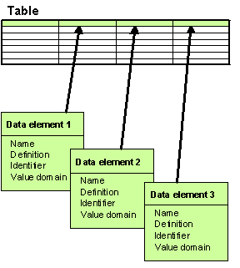Illustration 1: Data element tabular format

Attribute
Datasets, tables and elements in DD are defined by a set of attributes, the core set of which corresponds to ISO 11179 standard for describing data elements. The rest of the attributes are usually specific to Reportnet business rules and in any case the attribute set is flexible; an administrator can dynamically add/remove attributes to/from the system. Most common attribute of all is 'Name', standing for the name of the defined object. Other attributes could be for example 'Definition', 'Version', etc.
In ISO11179 two types of attributes are recognized, these type-names are also used in DD:
- Simple attribute
Every such attribute in its instance is a name/value pair. They represent the same concept of attribute as in ISO 11179 part 3. For example the mentioned 'Name', 'Definition' and 'Version' are a good examples of simple attributes.
NB! Note that simple attributes can have pre-fixed sets of allowable values, just like the elements. Often these values are some kind of codes.
- Complex attribute
A complex attribute in DD's context is almost the same as a simple attribute. The difference is that while a simple attribute is a name/value pair, a complex attribute is a set of name/value pairs. Every such pair is called a field. For example address would consist of country, city and street fields. A set of these fields combines a complex attribute value row. The set of these rows is what is called the complex attribute's value.

Important simple attributes when defining a data element are:
- Datatype
Indicates if the element’s values are strings, integers, booleans, etc. Also specifies if decimals are to be used, and how many decimals are accepted.
NB: For a Boolean datatype the allowable values according to ISO are ‘true’ and ‘false’.
- MaxSize/MinSize
The max/min length of a data element value in terms of digits or characters. For example if an element's MaxSize is 4, its value 'hello' is one char too long. Or if an element's MinSize is 5, its value '146' is one digit too short.
- MaxValue/MinValue
Can be applied only to data elements of numeric Datatype and they limit the element's numeric value. i.e. value '9.55' is too much if MaxValue is '9'.

Important complex attributes when defining a dataset, table or element are:
- SubmitOrganisation
The organisation that has added or changed the data element definition. This is mandatory to specify for all dataset, table and element definitions!
Fields of this complex attribute are: name, name abbreviation, contactPerson, e-mail, url, address, PhoneNr )
- RegistrationAuthority
Institution authorised to register the data definitions.
Fields of this complex attribute are: name abbreviation, name, address, contactPerson, urll

More about each and every attribute you can learn through using the DD, because each and every attribute in the DD user pages is provided with online help about its meaning and point.

Unique identification of datasets, tables & elements
Definitions of data elements, tables & datasets in DD are uniquely identified by an attribute, which is called Identifier.
Identifier is a character string used in DD to distinguish definitions of different elements, tables and datasets within the same context. Its maximum length is 50 characters and it must contain no white space! Identifiers will be used as tag names to distinguish elements in XML-formatted data reporting, so they must apply to the same rules, as do the XML tags.
A dataset Identifier must be unique!
A table Identifier must be unique within its owner dataset!
A data element Identifier must be unique within its owner table!
So logically a dataset is uniquely identified by its Identifier. A table is uniquely identified by its Identifier and owner dataset. A data element is uniquely identified by its Identifier and owner table.

User groups

Data suppliers
These are the users responsible for reporting data over Reportnet, according to reporting obligations in ROD database and legislation where the latter proceed from. The relation of such users to DD is as follows:
- According to Reportnet business process, ROD is where the a data supplier starts
- ROD’s obligation page provides the user with a link to a web site with the reporting guidelines document for that obligation. When the technical data definitions and as a consequence also guidelines are available in Data Dictionary, ROD will provide the link to DD to the definitions of data to be reported under that particular reporting obligation.
- So when definitions are in Data Dictionary, the data suppliers will get from Data Dictionary the detailed definitions of data to be reported, guidelines as a PDF-document and also templates for inputting their data.

Data definers
These are the users responsible and having the rights and skills to define the data for data suppliers to deliver. The best examples of such users are the ETCs, working as representatives of EEA. Because:
- DD is designed to withhold definitions of any of the data flows (reporting obligations ROs) registered in ROD
- Each RO in ROD has a 'report to' institution (i.e. CDDA to EEA)
- So it's natural that those institutions define "their" data flows
- Since EEA has delegated the data collection and definition tasks to ETCs, it is exactly they who shall be responsible for maintaining the data definitions and include in definitions the relevant texts for guidelines in DD. They can access both the read-and write functions in DD. Data definers also specify what delivery templates should be produced from definitions in Data Dictionary. Currently supported possible formats are Excel-templates, empty XML-files for filling directly from data supplier’s own datasystems, web-questionnaires and web-forms for filling on the web.

DD administrators
These are the users who basically have to maintain the functions that the other two user groups are using in DD. They don’t have to be involved in the reporting process, but they can nevertheless access all its functions and contents in DD, plus some administrative functions for managing the DD contents outside business rules (e.g. by force). The tasks of DD administrators are (in the order of importance):
- Maintaining (adding, editing, removing) attributes used in data definitions (i.e. maintaining metadata about the defined data).
- Cleaning the DD database of redundant "trash" and "leftovers" that might result from complications coming from simultaneous data definition and versioning cases. Over time DD shall evolve into a more foolproof dictionary with quite steady content where the possibility of such exceptions should be limited to the minimum.

Versioning of data definitions
DD keeps history of definitions of datasets and common elements.
Keeping history is needed for the case when a data supplier has downloaded a dataset definition some time ago, does not check if the definition has changed in the meantime and reports the data according to the old definition. Then in order to validate such data, the Validator needs to get the old definition. And that's why DD needs to keep the old versions of data definitions.
Every version of the definition of a dataset or a common element is uniquely identified by the dataset’s or element’s Identifier and the version number. In DD the version number is called CheckInNo. More on why such a name is used and on versioning details in general will be described in chapters 4.1 & 4.2.

Registration statuses
Each dataset and common element definition in Data Dictionary goes through a life cycle. Its phases are marked by Registration status (a.k.a simply status). The Registration status of a dataset or common element definition is specified by the data definers and can be any one of the following (in the descending order of “age”):
Released (marked with 5 ticks in the list of dataset definitions and common element list.
The definition is accepted by ETCs and EEA and is released for countries to use for download of technical guidelines and templates. Definitions in this status can be accessed by countries.
Qualified (marked with 4 ticks in the dataset- and common element lists)
This level is for closing discussions between ETCs and EEA. Definitions in this status cannot be accessed by countries.
Recorded (marked with 3 ticks in the dataset- and common element lists)
This level is for discussions between ETCs and countries if applicable. Otherwise the definition will skip this status and move directly to the Qualified status. Definitions in Recorded status can be accessed by countries.
Candidate (marked with 2 ticks in the dataset- and common element lists)
Definitions that are included in the Data Dictionary by the EEA or ETC data managers. This level is for opening discussions between ETCs and EEA. Definitions in this status cannot be accessed by countries.
Incomplete (marked with 1 tick in dataset and common element lists)
This can be existing definitions under consideration to be included in the Data Dictionary or new definitions under development where the Data Dictionary is used as a structuring tool or to test data flows. Definitions in this status cannot be accessed by countries.

Working copies and definitions in work
If a data definer is editing a data definition then that definition is locked for others to edit. In DD terms a definition in such a state is checked out (= locked for editing). If a definition is checked out, its working copy is created and that's what the data definer is working with. Nobody else can see the changes being made to the working copy. The original, even if locked for editing , is still readable and viewable for all.
NB! If a dataset definition is checked out, nobody can edit the definitions of its tables and elements. Not even the user who checked out (locked) the dataset definition!
NB! If a table definition is checked out (locked), the definitions of its elements, its parent dataset and other tables in that dataset cannot be edited by anybody. Not even the user who checked out (locked) the table definition!
NB! If a non-common element definition is checked out, the definitions of its parent table, parent dataset and other tables in that dataset cannot be edited by anybody. Not even the user who checked out (locked) the element definition!
The dataset definition that has one of its table or element definitions checked out, is said to be locked or in work. Similarly, the table definition that has one of its element definitions checked out, is said to be locked or in work.

Functionality overview
Data Dictionary’s functionality is divided according to the 3 user groups:
- All-users functionality
Available for all user groups.
- Data definers and administrators functionality
Available both for data definers and DD administrators.
- Administrators-only functionality
Available both for DD administrators only.

The rest of this document should give an overview about all the above functionality.
But the current chapter though contains only the over-all descriptions of the opening view and use cases for data suppliers and data definers, illustrated with figures.
Administrators-only functionality is not big, It is covered in chapter 5.
However, the opening view is the same for all and it is as follows.

Opening view
The opening view (figure 2) of the DD is divided into 5 sections:
- released dataset definitions
This is a list of quick-links to dataset definitions that have been officially released for data suppliers to use in live reporting.
- login window
This where one can log in. After successful login this area will display the user’s name instead of login inputs. Login is needed for maintaining data definitions and for administrative functionality.
- news
This is an area listing all the latest DD-related news.
- documentation
This area provides links to the text that explains the DD’s purpose, main concepts and functions.
- support
This is an area helping you to find the sources which to contact for feedback.

The opening view, as well as every other non-popup view of DD has a left pane containing the buttons that lead to the application’s main top-level functions from where you can descend to lower levels of DD functionality.
The pane also contains the Login button, enabling the data definers and DD administrators to log into the system. Once they do so, the pane will reveal more buttons to more functions, depending on the profile of the user name. A successful login will reload the current DD page and the Login button will be substituted by Logout.

All the non-popup views have a location bar right under the page header, displaying the location where you at the current moment in DD functions. It also contains the link to the application's opening view, so that you can always return back there.

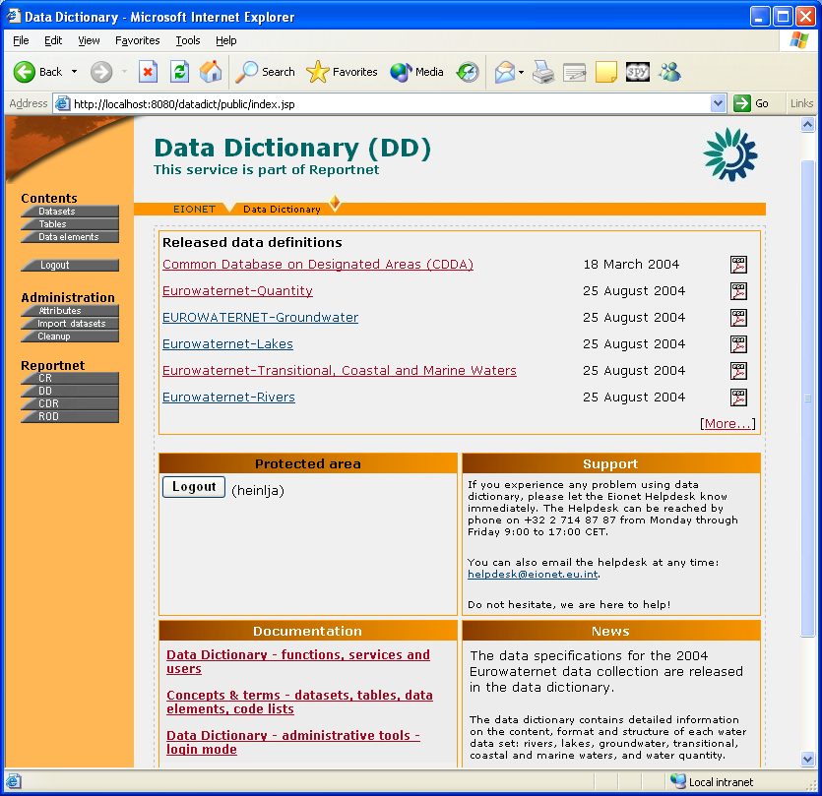Illustration 2: Opening view of the Data Dictionary

All-users functionality
At this moment all the users should have possibility to search and browse three kinds of data definitions – datasets, tables and data elements. Usually the functions for administrators are either invisible or they are disabled for use if the user has not logged in or is not in the administrators group. The use-cases for all users are described on figure 3. The use case figures can also be handled as navigation maps.
Illustration 3: Use-Cases for all users

Data definers and administrators functionality
In addition to all-user functionality, data definers and DD administrators have access to the functions covered in the use-cases in figure 4 (note that it also includes all use cases from all-users functions). These functions will become visible and/or available after successful login.
Illustration 4: Use-Cases for data definers and administrators

Administrators-only functionality
The use-cases on figure 5 describe the functions accessible only for DD administrators.
More on what they actually mean and contain is described in chapters below.
Illustration 5: Use cases for DD administrators only

Online help
Throughout the DD pages you can find question-mark icons with a white question-mark on a brown background. All these icons open a pop-up window with online help on the area/or function where the icon is located.
Also, most of DD pages have a brown-yellow PAGE HELP icon in the upper right corner. These icons open a pop-up window with general help and background information on the page you’re working with.

All-users functionality

Dataset definitions

Browse dataset definitions
You can view the list of dataset definitions (figure 6) by clicking Datasets on the left pane. For searching a particular dataset definition by some parameters, click the Search icon in the upper right corner.
This list always displays the latest versions of dataset definitions and it has at least 3 columns for all users. Dataset column contains the dataset’s short name, it is sortable, clickable and leads to the dataset definition view. Status indicates the definition’s Registration status and is sortable. Tables lists the tables in the given dataset. Each table is clickable and leads to the table’s definition view.
Data definers and administrators can also see the CheckInNo column which indicates the definition’s version. In addition, they can see checkboxes in front of dataset definitions they can delete. The checked definitions can be deleted by pressing the Delete selected button. New datasets can be defined by pressing the Add new button. Non-permanently deleted dataset definitions can be restored by clicking the Restore icon in the upper right corner. Both buttons and the Restore icon become visible only when the actions are permitted for the user.
If a dataset or table definition is locked for editing, it is marked in this list by a red asterisk.
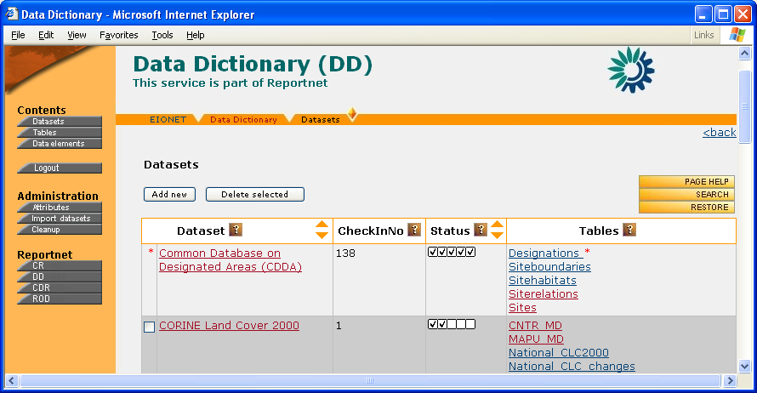Illustration 6: List of datasets

Search for a dataset definition
Dataset definition search page (figure 7) can be reached from the overall list of datasets (previous figure). It has several search criteria and more can be added by using the blue + icon below the criteria. Added criteria can be removed by using the blue - icon that appears next to the added criteria. Help on the meaning of every criterion can be found by clicking the ? icon in next to the titles.
Three radio buttons below the criteria enable to set the search precision. The search is invoked by pressing the Search button. Reset clears the criteria. If all the criteria are blank, the search return all the dataset definitions found in DD.
Data definers & administrators can also see the Add button for defining new datasets.
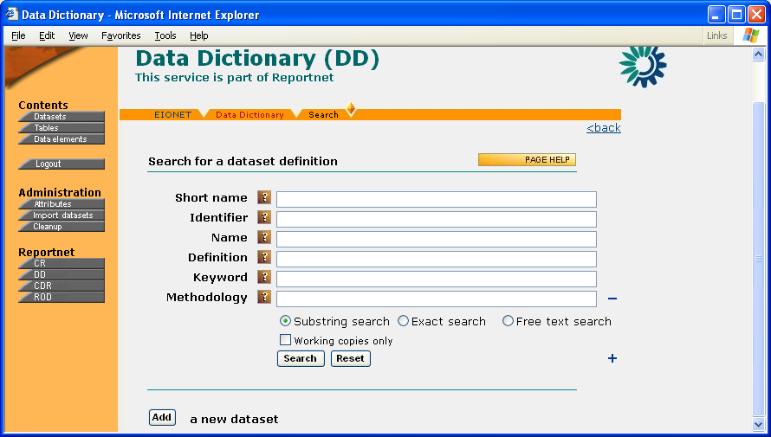Illustration 7: Search for a dataset definition

View a dataset definition
Dataset definition view (figure 8) contains all the details about the dataset’s definition. All the valued attributes (but only valued!) are displayed here. Simple attributes are displayed in the page’s upper part, complex ones at the page’s bottom. The ? icon in attribute titles opens the attribute definitions.
The upper part of the view also contains a section where one can download the definition in different formats (PDF, MS Excel, XML Schema, XML instance) and also additional documents if any have been uploaded. The PDF and MS Excel might be cached. In that case they will open quickly, otherwise it might take several minutes.
If there is a data model specified for this dataset, you will see its thumbnail displayed below the attributes (more on data model in chapter 4).
Following the model part is the list of dataset tables. Clicking on a table's name leads to its definition view.
The list of tables is followed by the list of obligations in ROD specified for this dataset, unless the definition is still uncompleted and the new obligation has not been imported to ROD, yet. This is a list of reporting obligations corresponding to this dataset in the Reporting Obligations Database (ROD). Its title, the legal instrument it belongs to and the link to the obligation’s details in ROD give each obligation.
In the upper right corner, users with relevant permissions can see the Edit, Delete and History buttons. The first one leads to the definition’s edit view, the second one opens the dialogue for deleting the definition’s version you’re looking at. History opens a popup with all versions of this definition listed.
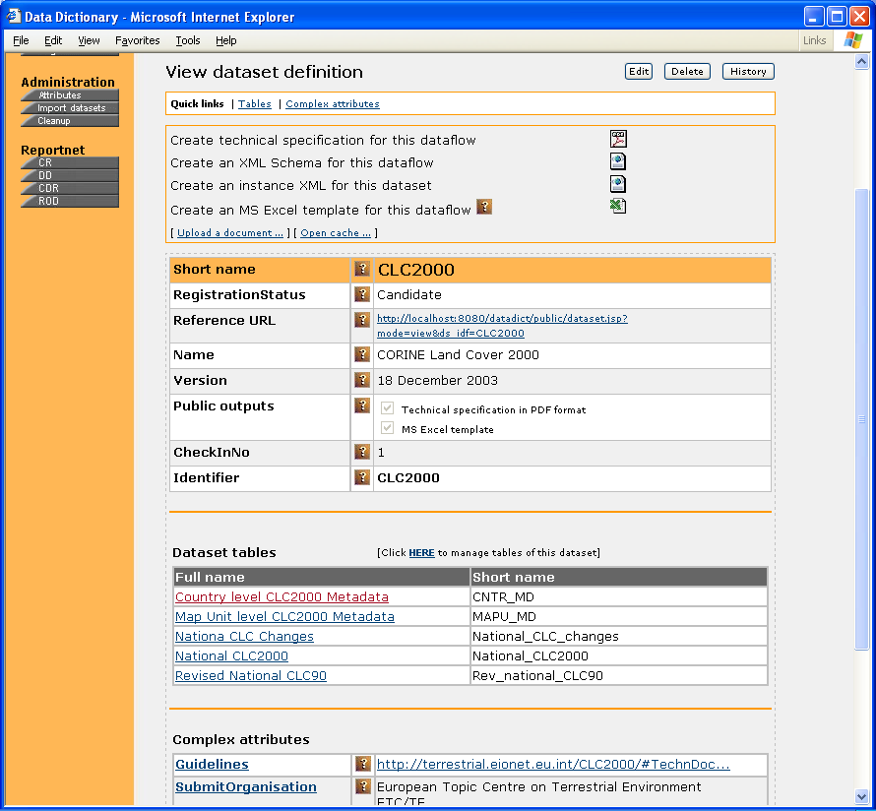Illustration 8: Dataset definition view

View a dataset definition history
The list of a dataset definition’s history can be reached by clicking History button in the dataset definition view. The list has 3 columns where CheckInNo is the version number, User is the name of the user who created the version and Date is the date of the version’s creation.
Clicking the CheckInNo closes the popup and opens the clicked version in the main window. And then you can take a look at this version just like you've been looking at latest versions.
NB! If a version is non-permanently deleted, it is not clickable in this list and is marked by the red D sign.

Table definitions

Browse table definitions
You can view the list of table definitions (figure 9) by clicking Tables on the left pane. For searching a particular table definition by some parameters, click the Search icon in the upper right corner.
This list always displays the latest versions of table definitions and it has 3 columns for all users. Table column contains the table’s full name, it is clickable and leads to the table definition view. Short name indicates the table’s short name, while Dataset contains the short name of the dataset where this table belongs. All 3 columns are sortable.
In the upper left corner of the list data definers and administrators can see the Add button which enables to define new tables.
If a table definition is being in work (locked for editing), it is marked in this list by a red asterisk.
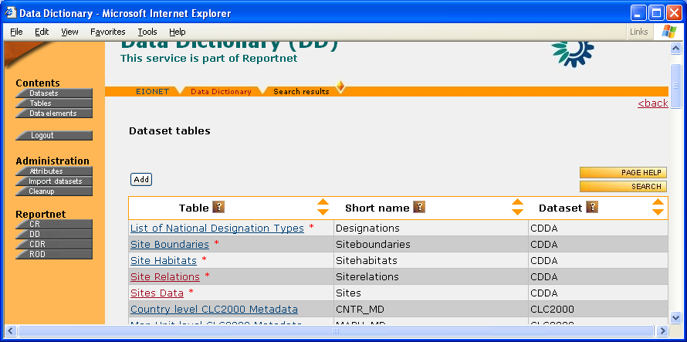Illustration 9: List of tables

Search for a table definition
The table definition search page can be reached from the overall list of datasets (figure above) and follows exactly the same rules of usage than those of dataset definition search page. So please see the chapter for the latter above.

View a table definition
Table definition view (figure 10) contains all the details about the table’s definition. All the valued attributes (but only valued!) are displayed here. Simple attributes are displayed in the page’s upper part, complex ones at the page’s bottom. The ? icon in attribute titles opens the attribute definitions.
The upper part of the view also contains a section where one can download the definition in different formats (MS Excel, XML Schema). In future this part will also include a link to view the web form template for this table if the form has been created to be used for data input from table definition in DD.
Between the simple and complex attributes sections you will see the list of elements in this table if any have been specified yet. NB! Note that if any of the elements have been defined as GIS elements, the list is split into two: the list of non-GIS elements is titled Metadata elements; the list of GIS elements is titled Elements and has an additional column listing the elements’ GIS type. More about this is available below in the chapter about GIS tables and GIS elements.
In the upper right corner, users with relevant permissions can see the Edit and Delete buttons. The first one leads to the definition’s edit view, the second one opens the dialogue for deleting the definition.
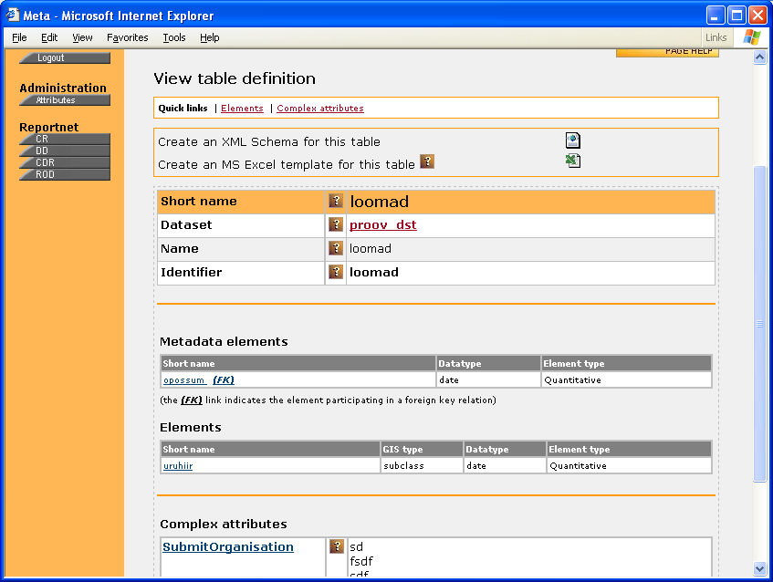Illustration 10: Table definition view

Data element definitions

Search for a data element definition
Element definition search page (figure 11) is reachable by clicking Data elements on the left pane. It looks much like the pages for searching dataset and table definitions. The criteria set is manageable by using the blue + and – icons for adding and removing criteria. Help on every criteria is available by clicking the ? icons in their titles. Two additional radio buttons that you don’t see on table and dataset search pages are for specifying whether you’re looking for non-common or common elements only.
A useful feature for data definers and administrators is the Working copies only checkbox. When checked, it performs a search for the user’s working copies only. Also the features only available for data definers and administrators are the two Add buttons for defining new common or non-common elements.
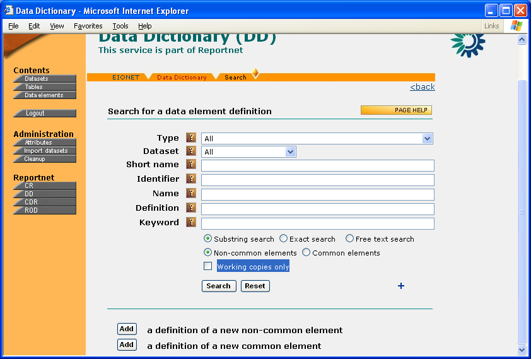Illustration 11: Element definition search page

Browse data element definition search results
The look of the data element search result list depends on whether you searched for common or non-common elements. The list for non-common elements (figure 12) has always 4 columns. The Element column contains the element’s short name, is clickable and leads to the element definition view. The Table and Dataset columns indicate the table and dataset where the element belongs. Finally, the Type indicates whether this is an element with fixed values or quantitative values. All columns are sort able. If an element is checked out (locked for editing) or its dataset is in work, it is marked with a red asterisk. But only for data definers and administrators.
The list for common elements (figure 13) has at least 3 columns for all users. The Element column contains the element’s short name, is clickable and leads to the element definition view. The Status column indicates the element’s Registration status. Type, again, indicates the element’s type. All these columns are sortable. In addition, data definers and administrators can see a 4th column- CheckInNo, indicating the element’s version. If an element is checked out, it is marked with a red asterisk. But only for data definers and administrators.

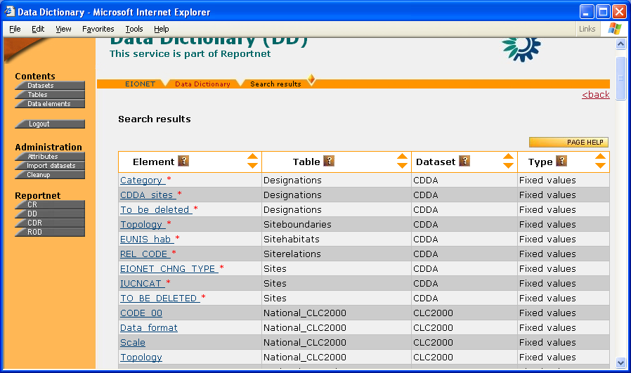Illustration 12: Search result list for non-common elements

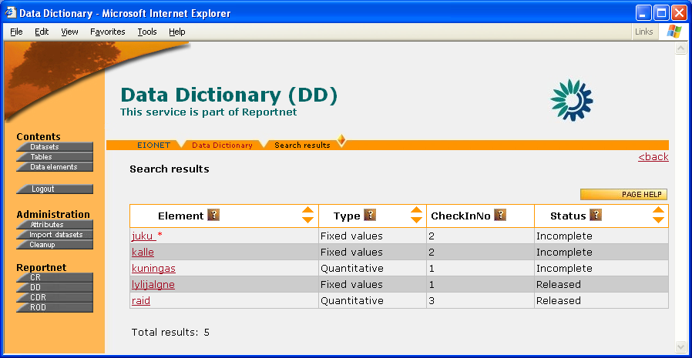Illustration 13: Search result list for common elements

Data element definition view
Element definition view (figure 14) contains all the details about the element’s definition. All the valued attributes (but only valued!) are displayed here. Simple attributes are displayed in the page’s upper part, complex ones at the page’s bottom. The ? icon in attribute titles opens the attribute definitions.
For data definers and administrators the upper part of the view also contains a section where they can download the definition in XML Schema format.
Between the simple and complex attributes sections one can see either the list of fixed values (titled allowable values here) or the list of suggested values, depending on the element’s type. Elements with quantitative values can have suggested values. Both lists have 3 columns- the value itself, its Definition and Short description. If no allowable or suggested values have been specified yet, you will see no list.
As an addition in this view, common elements have a list of tables using that common element. The list is given in two columns: table name and dataset name. Both are clickable and lead to the respective definition views.
In the upper right corner, users with relevant permissions can see the Edit and Delete buttons. If this is a common element, they can also see the History button, which opens the history of the element in a popup window. Non-common elements are not version, so they don’t have this button.

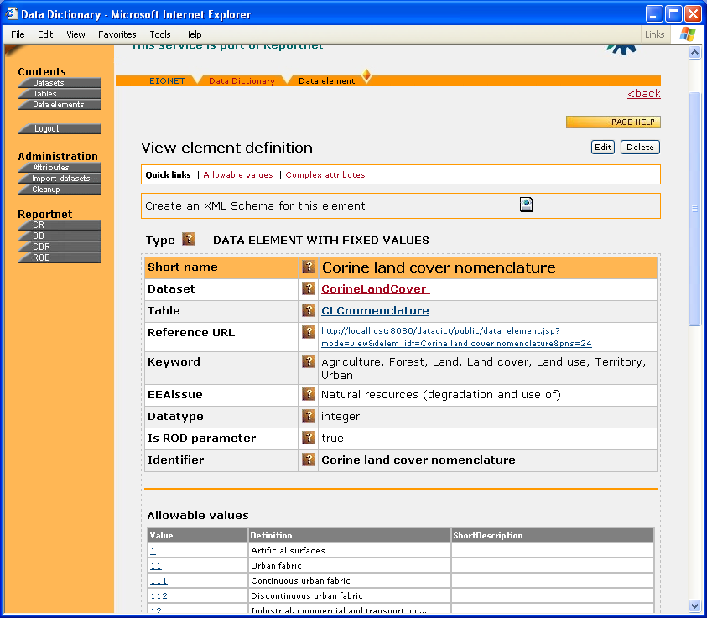Illustration 14: Data element definition view

View a common element definition history
The list of a common element definition’s history can be reached by clicking the History button in common element definition view. The list has 3 columns where CheckInNo is the version number, User is the name of the user who created the version and Date is the date of the version’s creation.
Clicking the CheckInNo closes the popup and opens the clicked version in the main window. And then you can take a look at this version just like you've been looking at latest versions.

GIS tables and elements
Some of the tables defined in DD might contain GIS (Geographic Information System) data. In DD terms, data elements (i.e. table columns) containing such data are called GIS elements. Tables containing such elements are called GIS tables.
You can distinguish GIS elements in DD by the value of the GIS field in their definitions. If such a field is missing from the definition’s detailed view then it means that the defined data element is not a GIS element. Otherwise the GIS field can have one of the following values, called the GIS types:
- [blank]
- class
- subclass
- subtype
Data definers and DD administrators can assign these values in the edit views of data elements (look in chapter 4).
The moment an element in a table is defined as a GIS element, the moment the table becomes a GIS table and it’s detailed view becomes slightly changed. More precisely, the list of elements is split into two: one for the so-called normal elements and one for the GIS elements. The 1st one is titled Metadata elements, the 2nd one is titled simply Elements (look at figure 15) where the GIS type is reflected in the GIS type column.

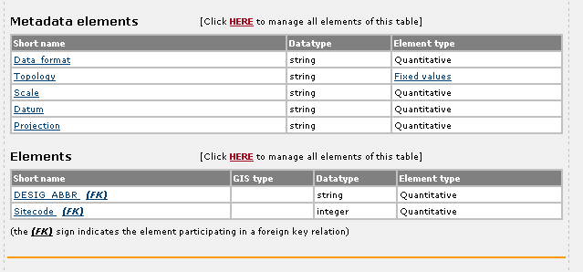Illustration 15: Elements list of a GIS table

Data definers & administrators functionality
Functions for data definers and DD administrators will become visible if they log in using the Login button on the left pane. These functions are all in one way or another related to editing the content of the DD. Most notably they include the management of definitions of datasets, tables and elements. In addition, DD administrators can manage the definitions of attributes, but this is covered in chapter 5.

Simultaneous editing- checking in & checking out (Or ‘Lock-for-editing & Release changes & Undo changes)
Before we can proceed to editing the DD content, there are some things essential to know beforehand.
It is natural that two users might want to edit the definition of the same data element, table or dataset simultaneously at one time. That might cause a lot of confusion and in order to prevent it, counter-measures have been taken in DD.
If a user wants to edit an existing or add a new data element, table or dataset, then that object will be locked and others cannot edit it. In DD terms it is also called checking out. Once an object is checked out (= locked for editing), a working copy of that object is created and that's what the user will be working with. User in such a stage is also called working user. During that time no other user can edit the checked-out (locked) object, nor can they see any of the changes that the working user is doing.
Once the working user is done with edits and the object is ready to be released and published for others, he/she will check in the working copy. As a result, the object will be unlocked and the changes made, it will become visible for other users as well. The object is ready for others to edit.
Changes to a working copy can also be cancelled, by performing undo check-out (= Undo changes & Unlock). In that case all of the changes made will be lost and the object remains as it was before check-out.
Since definitions of datasets, tables and non-common elements are in direct dependencies in between each other, it is natural that checking out a dataset definition might have implications on its tables and elements and vice versa- changes done to the definition of a non-common element might have effects on its table and/or dataset. To avoid confusion, DD has the following very strong restriction:
Checking out a dataset definition, or its comprising table definition or the latter's comprising element definition will lock the whole dataset definition for edits by anybody! Only the check-out (locked for editing) definition can be edited and naturally by the user who checked out. So a dataset definition (including the definitions of its comprising tables and elements) can be edited only by one user at a time!
Since common elements are not in dependent relations with any tables or datasets, they do not have effects on datasets and tables when checked out. Nevertheless, a checked-out common element can be edited only by the user who checked it out.

Versioning details
As it was told in chapter 1, DD keeps history of definitions of datasets and common elements.
Whenever checking in the definition of a dataset or the definition of one of its tables or elements, you can tell the DD to create a new version of that dataset definition by checking the box titled Update the dataset definition's CheckInNo when checking in (more to follow in chapters below). This is also why the version number in DD is called CheckInNo- it is last check-in number in row. Also, when you delete the definition of a table or a non-common element, you will be asked if you want that deletion to create a new version of the parent dataset. This way data definers and administrators can control the versioning of datasets.
Definitions of common elements are versioned too. Whenever checking in the definition of a common element, you can tell the DD to create a new version of that element definition by checking the box titled Update this element definition's CheckInNo when checking in (more to follow in chapters below). This box, however, is not displayed if you are just creating the very first version of a common element (i.e. it has no previous version to update). This way data definers and administrators can control the versioning of common elements.
NB! Only the latest version of a dataset, table or element definition can be deleted! You cannot delete history. To lose all knowledge of a dataset or common element, you have to delete all of its versions one-by-one.

Dataset definitions

Add a new dataset definition
Dataset definition adding view (figure 16) can be reached from 2 places- clicking Add on the dataset definition search page or clicking Add on the dataset definition search results page.
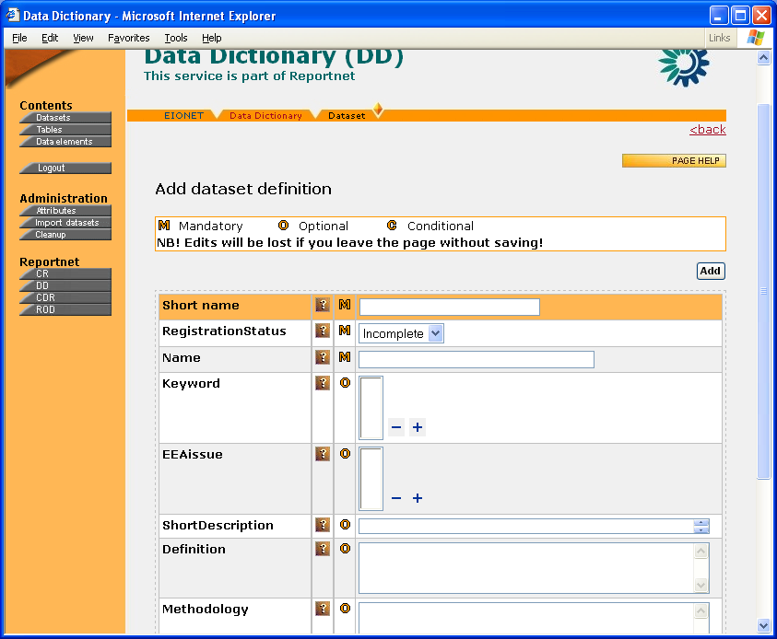Illustration 16: Dataset definition adding view
A dataset definition is uniquely identified by its Identifier. You must fill at least the mandatory fields (indicated by (M)). Once you've done the filling, press Add to submit the data. As a result, the DD will create a working copy of the definition you've added and will lead you to its editing view. For the latter please see the next chapter.
If an attribute can have several values then you can add these values by using the blue +/- icons in the lower right corners of attribute boxes.

Edit dataset definition
Dataset definition editing view (figure 17) can either be reached from the view of adding a new dataset definition or from a dataset definition view by clicking the Edit button.
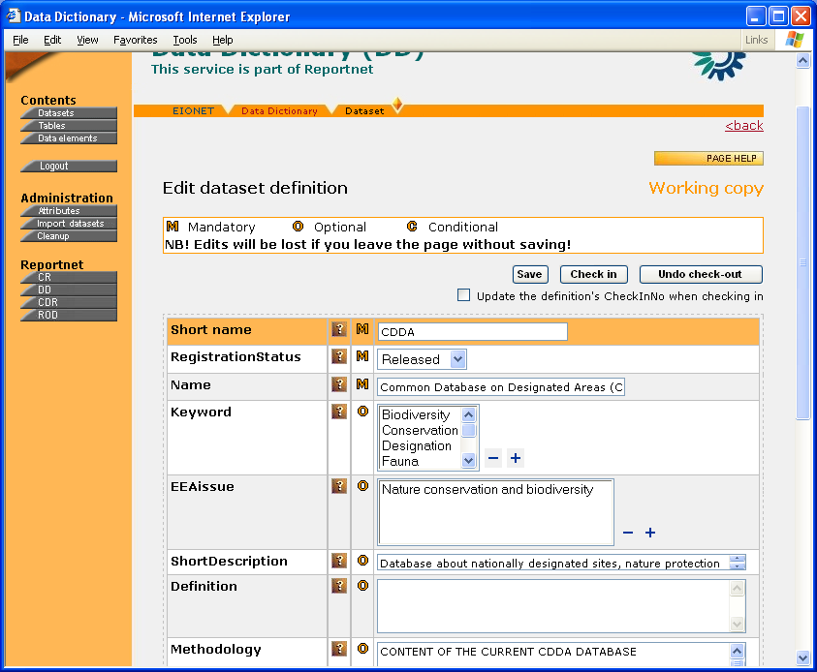Illustration 17: Dataset definition edit view
Once you've managed to reach the dataset definition edit view, you're also working with a working copy (a warning in the upper right corner lets you know). The dataset definition is checked out (=locked for editing), meaning nobody else can edit it and nobody else can see the changes you are making. You submit your changes by clicking Save. You can do it for as long as you want and still nobody can see what you’ve submitted. It is only when you click Check in when the dataset is released for others to edit and everybody can see the changes you made. If you want your changes to trigger a new version of this dataset definition, check the relevant box below the buttons in the upper section.
There's also a 3rd button- Undo check-out. This will lose all the changes you have done and the working copy will be deleted from the database. The dataset definition will be released for others to edit.
Following the section of buttons is the list of editable attributes. If an attribute can have several values then you can add/remove these values by using the +/- icons in the lower right corners of attribute boxes.
The page bottom has links to other editable information on this dataset: data model, table definitions, links to ROD, complex attributes. NB! Note that table definitions, however, cannot be edited while the dataset definition itself is being edited! Once you’ve edited any of those parts, you must come back to this dataset definition edit page and click 'Check in' in order for the changes to take effect.
NB! If you are creating a brand new dataset definition, you must supply the SubmitOrganisation complex attribute before you check the definitions in.
See the chapter about working with complex attributes.

Delete dataset definition
There are two ways to delete a dataset definition. The first and most recommended one is to do it from dataset definition view by using the Delete button. Another way is to do it from the overall list of dataset definitions or dataset search result list. Both lists have checkboxes for selecting the desired dataset definitions and Delete button for taking the action.
Note the following important points:
- A dataset definition can only be deleted when it is the latest version, it is not in work by anybody and the user has the permission to delete it. If one of these conditions is not fulfilled, the checkboxes and/or buttons for deletion are either not displayed or you will get rejection from DD when you try to delete.
- Whenever you delete a dataset definition, you are deleting a concrete version (labelled with CheckInNo) of that definition. And it is always the latest version. So if you want to completely remove all knowledge about a dataset, you must delete all of its definition versions one by one!
- You cannot delete a working copy! No delete buttons are displayed for it. The only way to get rid of a working copy is to go to its edit view and click Undo check-out (=undo changes and release for editing).

Working with the definition of tables in a dataset
You can reach the list of definitions of tables of a dataset (figure 18) from the dataset definition view (there’s a link for that). The list has 3 columns. Name is the table’s full name, it is clickable and opens the table definition view. Short name speaks for itself, while the Definition column contains the main idea of the table.
In the page header there's an Add new button, which leads to the view for adding a new table. By using the checkboxes and Delete button, you can delete the checked tables (more about deleting tables is in chapters below).
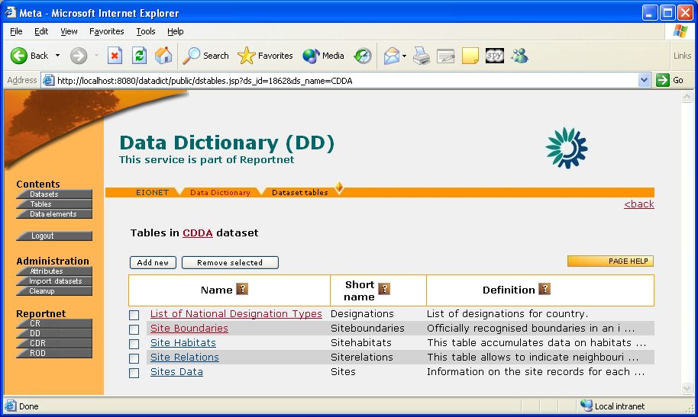Illustration 18: List of table definitions in a certain dataset

Dataset models
As mentioned above, the dataset definition edit page has a link to the dataset’s data model.
The role of the data model is to visually describe the dataset structure (down to the level of elements if needed) in a modelling language. For now, models can be attached to datasets only as simple image files. The DD recognizes 3 image types- JPG, GIF and PNG. So in order to provide a dataset definition also with its data model, you should first draw the model with your modelling tool and then save it as a file of one of those 3 types. A screenshot of a dataset model view is given on figure 19.
There can be two models given to a dataset. A simple model should describe the structure only on the tables level, while in the detailed model you can add as many details as you'd like. The two models are situated on the model view's separate tabs.
To add a model, click on its tab (simple or detailed) and specify the image file location either on your local file system or in the web. And then press Upload. As a result, the image is downloaded from given location and stored into DD file system.
There's also a button for removing the model.
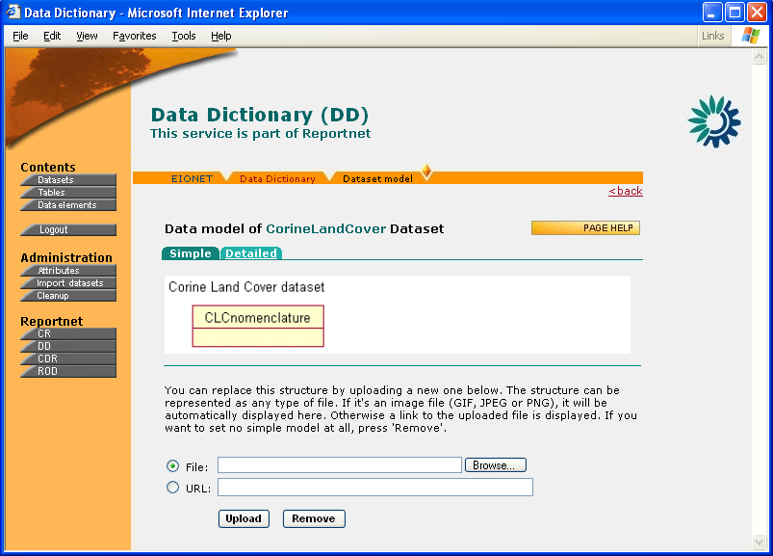Illustration 19: Dataset model view

Uploading documents for a dataset definition
For every dataset definition a data definer can upload documents (or actually any files for that matter) that the users can download as additional information in relation to the dataset. This can be done by pressing the [ Upload a document ... ] link in the dataset definition view (one must be logged in to see it). The link opens a new window (figure 20) where one can do the upload.
Using the Browse button, one must select the file he/she wants to upload. As an option, in the Title box one can specify the title that DD will display for the uploaded file in the section of downloads for end users. If the title box is left empty, DD will use the uploaded file's name as the title.
Pressing Upload will upload the selected file into DD. Pressing Clear will clear the inputs. The uploaded document will appear as a downloadable in the upper part of the dataset definition view. All uploads are automatically visible for end users. Data definers will also see a deletion icon (a red cross) next to the downloadable. Pressing that icon will remove the downloadable from DD.
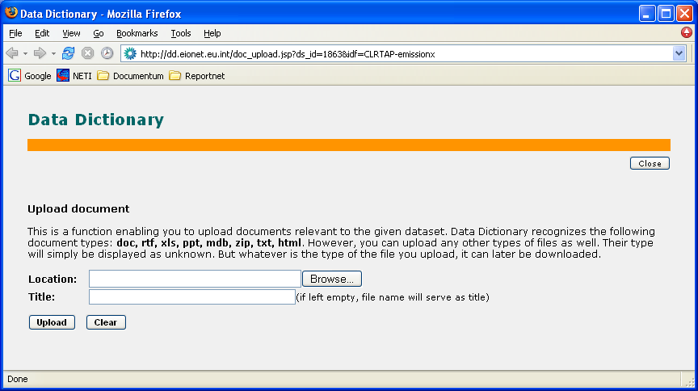Illustration 20: Document upload view

Dataset definition’s links to ROD
The list of reporting obligations corresponding to a dataset definition can be managed by clicking the relevant link in the bottom part of the definition’s edit view. It will open a view like that on figure 21. The view lists the already specified obligations and enables to add more by clicking the Add new button. A click on this button connects on line and on the fly to ROD and returns the list of all obligations defined in there. In that list you can select obligations by clicking their titles.
To remove existing links, use the Remove selected button and the checkboxes for selection.
Once you've managed editing links on this page, you must return to the dataset definition's edit view and click Check in to submit your changes.

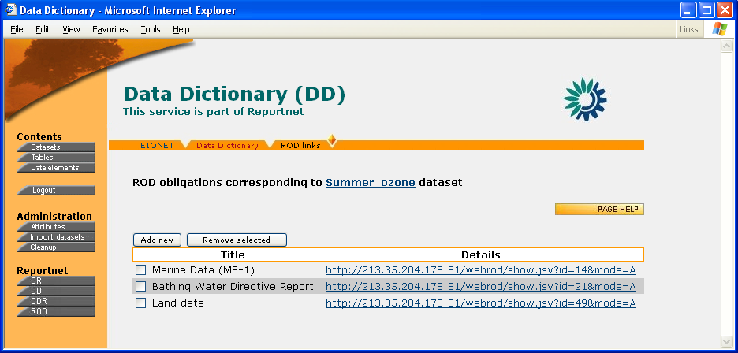Illustration 21: Working with a dataset’s links to ROD

Restoring non-permanently deleted dataset definitions
Above it was described how to delete a dataset definition. Whenever you do that, DD asks if you want to delete the definition permanently. If you choose no, DD will keep the definition for later restoration if needed. The list of restorable dataset definitions (figure 22) can be reached by clicking the Restore icon in the overall datasets list. You can restore the desired definitions by checking the relevant boxes and clicking Restore selected. The Delete selected will delete selected definitions permanently.
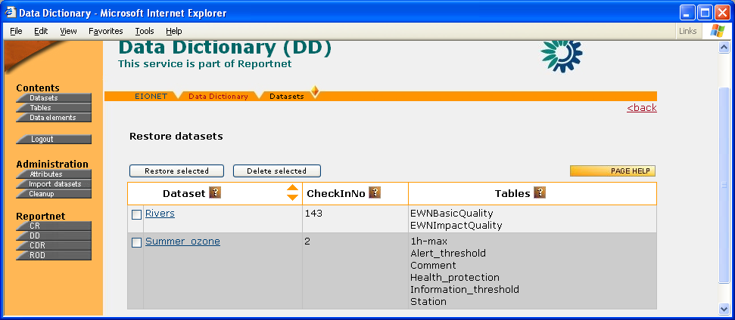Illustration 22: Restoring dataset definitions

Table definitions

Add a new table definition
Table definition adding form (figure 23) can be reached from 3 places- clicking Add on the table definition search page, clicking Add on the tables list or clicking Add new in a dataset tables list. In the first two cases you must first specify the dataset into which you want to add the new table. There's a dataset select box for that. In the latter case the dataset must NOT be checked out!
Once you have selected the dataset or reached the table adding view from a dataset tables list, the situation will be much like it was in dataset definition adding view. You must specify the table's Identifier, which has to be unique in the dataset. Fill at least the mandatory attributes (marked by (M)) and click Add. As a result, the DD will create a working copy of the table definition you've added and will lead you to its editing view (see 2 chapters below).
If an attribute can have several values then you can add/remove these values by using the blue +/- icons in the lower right corners of attribute boxes.
The Copy button also in the upper right corner enables to define a new table by copying the attributes and elements of another table in another dataset. More about this in the following chapter.
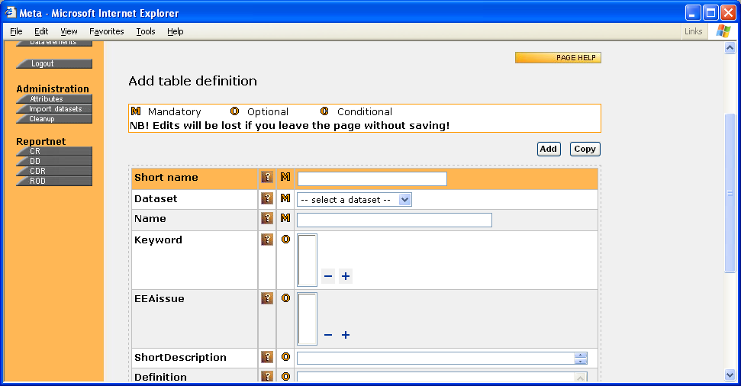Illustration 23: Table definition adding view

Copy table definition
Sometimes you might want to define a new table with exactly the same attributes and/or structure (i.e. set of elements) as another table in another dataset.
In order to do so, go to the ‘Add table definition’ view, fill the new table’s mandatory attributes and click Copy. This will open a popup where you can search for the definition of the table you want to copy. In the search result list you can select the desired table by clicking its link. As a result, DD closes the popup and leads the main window to the edit page of the new table definition (see the next chapter)) where everything but the mandatory attributes has been taken from the table you selected in the popup.

Edit table definition
Table definition editing view (figure 24) can either be reached from the view of adding a new table definition or from a table's definition view by clicking the Edit button.
The principles for editing a table definition are pretty much the same as they were for dataset definitions. You're working with a working copy, you save your changes by pressing Save, you publish them for others and release the definition by clicking Check in, and if you want to cancel your copy and restore the previous situation then you click Undo check-out (= undo changes & unlock ).
When checking in, you can tell the DD to update the dataset’s version (i.e. CheckInNo) by checking the relevant box below the buttons.
If an attribute can have several values then you can add these values by using the blue +/- icons in the lower right corners of attribute boxes. However, there’s an important point! If you see some attribute values un-editable then it means they have been inherited from dataset level. More about attribute inheritance is in the chapter 5.
The page bottom has a link for managing the definition’s complex attributes.
NB! If you are defining a brand new table in a dataset, you might have to supply the SubmitOrganisation complex attribute, before you can check in. But this is only if it hasn’t been inherited from the dataset’s definition already. And this in turn depends on whether the SubmitOrganisation has been defined inheritable.
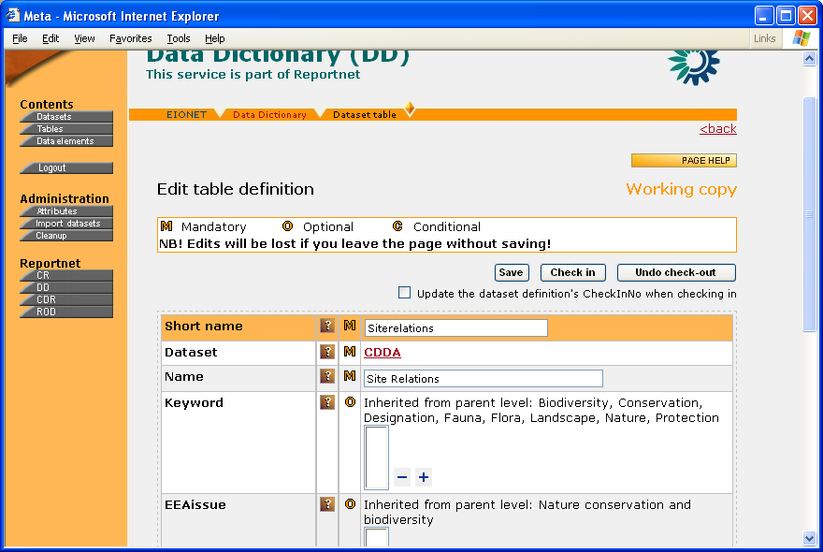Illustration 24: ‘Edit table definition’ view

Delete table definition
There are two ways to delete a table definition. The first and most recommended one is to do it from table definition view by clicking the Delete button.
Another way to do it, is to use checkboxes and the Remove selected button in the view for working with a dataset's tables (see above). This way you can delete multiple tables.
Note the following important points:
- A table definition can only be deleted from its dataset’s latest version, if the dataset is not in work by anybody and the user has the permission to delete it. If one of these conditions is not fulfilled, the checkboxes and/or buttons for deletion are either not displayed or you will get rejection from DD when you try to delete.
- Deleting a table definition means that DD will create a new copy of the table’s dataset, where that table is missing. DD will also ask if you want the dataset’s new copy to have a new version number (CheckInNo) and keep the previous copy.
- You cannot delete a working copy! No delete buttons are displayed for it. The only way to get rid of a working copy is to go to its edit view and click Undo check-out.

Working with definitions of elements in a table
You can reach the list of a table’s element definitions (figure 25) from the table’s definition view (there’s a link for that). The list has at least 3 columns. Short name is clickable and opens the element’s definition view. Datatype indicates the type of the element’s values while as Element type indicates if the element has fixed values or quantitative values. In the case of fixed values, Element type is clickable and opens the list of the fixed values specified.
If the table has any GIS elements, there’s also a 4th column in this list. It is titled GIS and indicates the element’s GIS type. For non-GIS elements is says ‘no GIS’.
The page header has a section for defining new element definitions. You have to provide the new element’s Identifier and Type and click Add or Copy. This will take you to the view of adding a new element definition (see chapters below). The checkboxes and the Delete button can be used for deleting checked definitions.
The Link button enables to include common elements into the table. The button opens a popup where you can search for common elements and select the desired by clicking the elements listed in the search result.
As a special feature, you can also change the order of the elements in the table. Just click on an element row (the click paints the row into light blue), use the classic moving icons on the right and finally click Save order to store the new order.
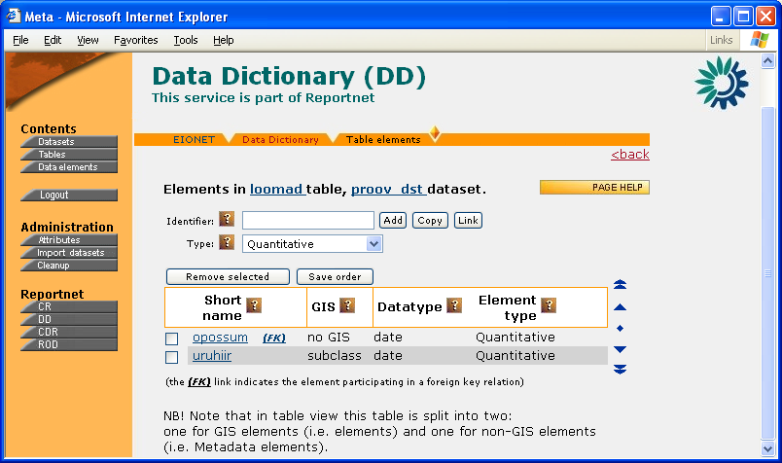Illustration 25: Working with elements in a table

Adding images to table definitions
DD enables to illustrate a table definition with images as long as they are of JPG, GIF or PNG file type. This can be done by using the so-called image attributes. It’s an attribute whose value is an image. Figure 26 illustrates how the Descriptive image attribute looks in table definition view. The image is displayed as a thumbnail. Clicking the thumbnail opens the image in a separate window where you can see it in full size.
In order to edit the image attributes, you must go to the table definition edit view. There the thumbnails will become links titled [Click HERE to add image]. The link opens a popup like that on figure 27. The form in the popup enables you to upload new images (by browsing them on your local PC) and remove selected ones.
NB! Please note that all images ever uploaded into DD, whether as dataset models or illustrative images for table definitions, must have unique file names, because they’re all stored in the same directory on DD server. So name your images carefully.

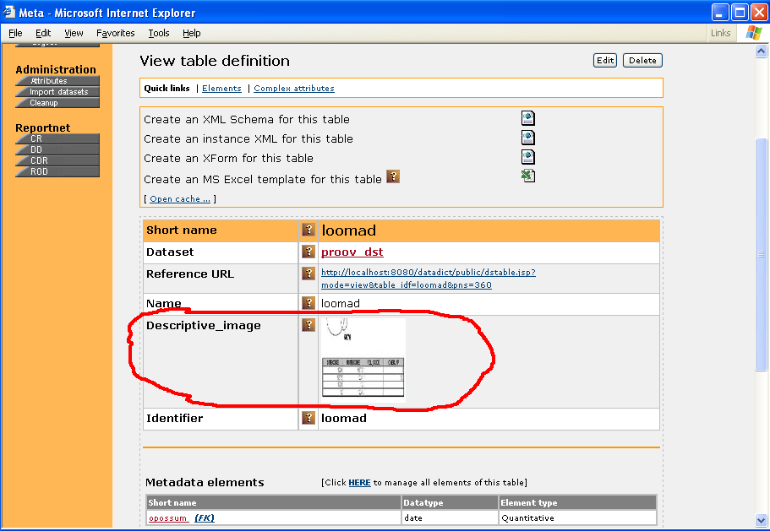Illustration 26: Image attribute in table definition view
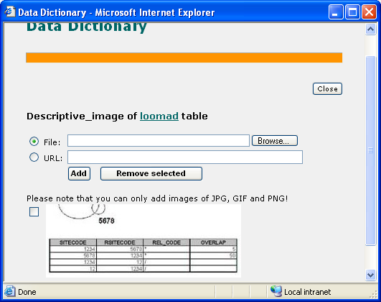Illustration 27: Image attribute window

Data element definitions

Add a new data element definition
Data element definition adding view (figure 28) can be reached in 2 ways- clicking Add on the element definition search page or clicking Add in the list of definitions of elements in a table (see chapters above). In the latter case the table must NOT be checked out (locked for editing)!
The page lists the definition's simple attributes whose values you can specify. Every simple attribute is a name/value pair. Some simple attributes can have several values at the same time. You can define or remove such values by using the blue +/- icons next to the inputs. The rest of the information on this element definition you can specify once you've submitted the simple attributes by clicking Add in the upper right corner. This will create a new element definition and lead you to its edit page
Unlike non-common elements, the common elements are versioned and they have a Registration status. Also, unlike non-common elements, the common ones are versioned and the version number is called CheckInNo. For more on Registration status and versioning, see the chapter about the DD’s basic concepts above.
NB! If you did not reach this page from the list of element definitions in a table, the element’s type (fixed values or quantitative values) and parent dataset have not yet been selected. If so, then these are the first inputs you must specify on this page, because they will reload the page and you will lose all other inputs.
If this is a non-common element, you will see the Copy button in the upper right corner. It enables you to create the new element definition by copying an existing one. More about this is in the next chapter.

Copy a non-common element definition or convert it to common element
Sometimes you might want to define a new non-common element with exactly the same value domain and non-mandatory attributes as another element in another table, possibly in another dataset as well.
In order to do so, go to non-common element definition adding view, fill the new element’s mandatory attributes and click Copy. This will open a popup where you can search for the definition of the element you want to copy. In the search result list you can select the desired element by clicking its link. As a result, DD closes the popup and leads the main window to the edit page of the new element definition (see the next chapter)) where everything but the mandatory attributes has been taken from the element you selected in the popup.
NB! If you want to convert a non-common element definition into common one, go to the common element adding view and follow exactly the same copy procedure!
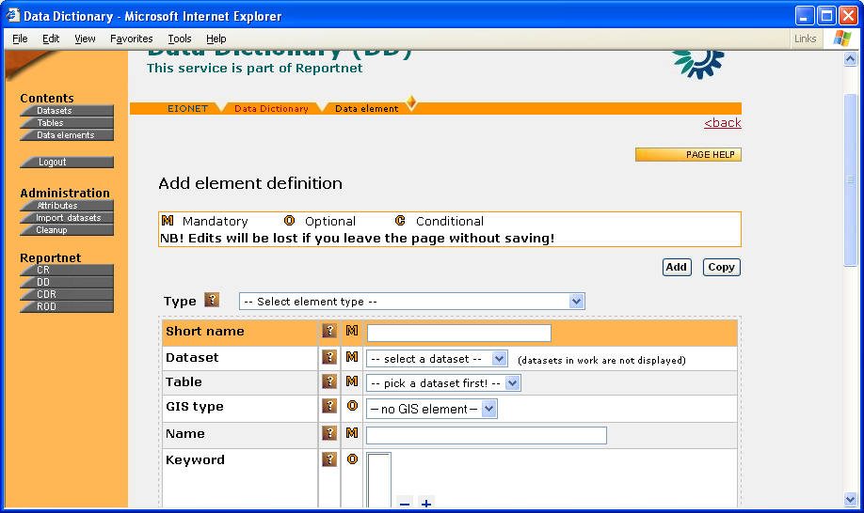Illustration 28: Data element definition adding view (non-common element)

Edit data element definition
Element definition editing view (figure 29) can either be reached from the view of adding an element definition or from an element's detailed view by clicking the Edit button.
The principles for editing an element definition are the same as they were for tables. You're working with a working copy, you save your changes by pressing Save, you publish them for others and release the dataset by clicking Check in, and if you want to cancel your copy and restore the previous situation then you click Undo check-out.
When checking in a non-common element, you can tell the DD to update the parent dataset’s CheckInNo as well. This can be done by checking the relevant checkbox.
When checking in a common element, you can tell the DD to update the element’s CheckInNo as well. This can be done by checking the relevant checkbox. Note that when you do this, the new version will have no links to any tables! If you just choose to overwrite the definition, the edits will also become automatically reflected in the tables where the common element is used!
If an attribute can have several values then you can add these values by using the blue +/- icons in the lower right corners of attribute boxes. If this is a non-common element and you see some attribute values un-editable, it means they have been inherited from dataset level. More about attributes inheritance is told in chapter 5.
The page bottom has links to the element’s complex attributes and fixed values/suggested values (depending on the element type). NB! You cannot edit the fixed values of an element of boolean data type. They are set to true and false.
If this is a non-common element, you will also see the link for editing its foreign key relations.
NB! If you are defining a brand new non-common element, you might have to supply the SubmitOrganisation complex attribute, before you can check in. But this is only if it hasn’t been inherited from the dataset’s definition already. And this in turn depends on whether the SubmitOrganisation has been defined inheritable or not.

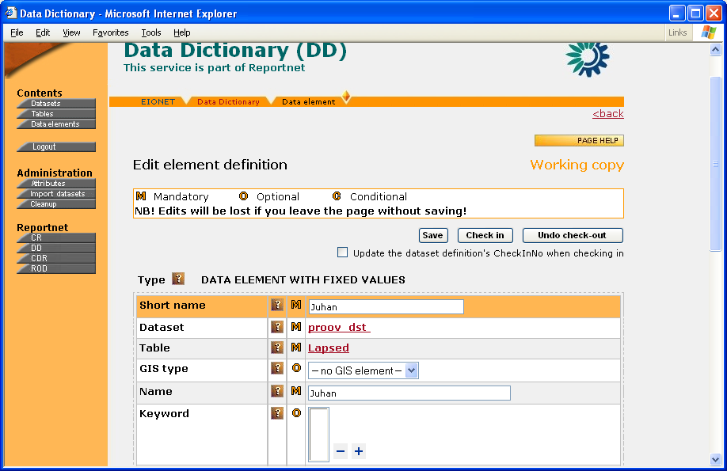Illustration 29: Data element definition editing view (non-common element)

Delete data element definition
There are 2 ways to delete a data element definition. The first and the recommended one is to do it from the element’s definition view by clicking the Delete button. The other way is to use checkboxes and the Delete button when working with elements in a table.
Note the following important points:
- A non-common element definition can only be deleted from its dataset’s latest version, the dataset must not be in work by anybody and the user must have the permission to delete it. If one of these conditions is not fulfilled, the checkboxes and/or buttons for deletion are either not displayed or you will get rejection from DD when you try to delete.
- Deleting a non-common definition means that DD will create a new copy of the parent dataset, where that element is missing. DD will also ask if you want the dataset’s new copy to have a new version number (CheckInNo) and keep the previous copy.
- Only the latest version of a common element definition can be deleted. It can be deleted only permanently.
- Great care must be taken into deleting a common element definition, because it might be used in some tables and/or referenced by other applications. Nevertheless, DD does not prohibit you from deleting a common element definition, but at least it warns you about the possible sequences.
- You cannot delete a working copy! No delete buttons are displayed for it. The only way to get rid of a working copy is to go to its edit view and click Undo check-out (=Undo changes & unlock).

Managing the fixed values of data elements
As you know by now, a data element can be defined to have values only from a pre-fixed set and it’s worth enough to call it a special type of elements.
In order to let the data supplier better know what a concrete fixed value means or stands for, a data definer can define attributes for fixed values. For example if an element like StationType can have values like Flux or Representative, then its reasonable that all such fixed values have an attribute called Definition and it defines what the given value actually means. So the Definition attribute, which is common to datasets, tables and elements, is also used for fixed values. And one can define more attributes for fixed values according to guidelines in the chapters below.
NB! Please note that you are not allowed to work with fixed values, unless the element is checked out.

Fixed values list
As mentioned in chapters above, you can reach the manageable list of fixed values by clicking the ALLOWABLE VALUES link in an element's detailed view. You will see a list which you can manage by clicking Edit in the upper right corner. As a result, you will be taken to a view like that on figure 30.
The list is given by 3 columns – Value, Definition, Short Description. While Value speaks for itself, the other 2 columns are the value's definition attributes. Value is clickable and leads to the value's edit view (see next chapter). Please note that an element cannot have two fixed values with same value.
New values can be added by using the value's input box and Add button on top of the list. The checkboxes and the Remove button enable to remove existing values.
Another option for adding values is to import the whole value list. Import button leads the user to the import page. See chapter 5 about importing data into DD.

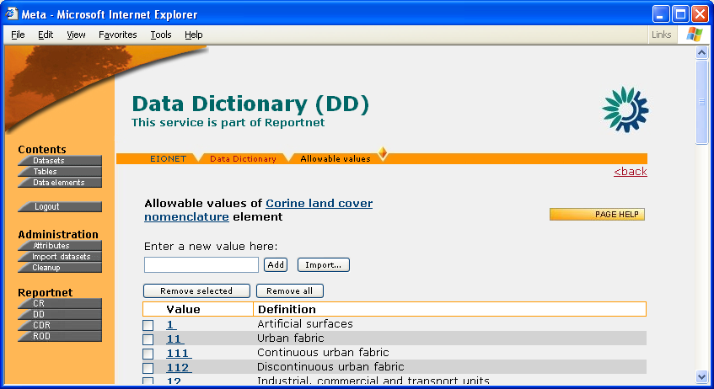Illustration 30: Manageable list of fixed values

Defining a fixed value
Above it was described how to add fixed values to an element. To give the values also a definition and a meaning, click the desired value in the fixed values list. You will be taken to a page where you can set the value’s Definition and ShortDescription. The Save button enables to save whatever you specified. The Delete button enables to delete the value.

Managing the suggested values of data elements
Elements with quantitative values can have suggested values, i.e. values that the data element definition suggests if the data supplier is unsure what kind of values to submit..
You can reach and manage suggested values by clicking the SUGGESTED VALUES link in the edit view of a data element with quantitative values. The rest of the procedures are exactly like those for fixed values explained above!

Foreign key relations
Since tables in a reported dataset might have foreign key relations to each other, DD enables to define them as well.
A foreign key relation between two tables is handled simply by defining a foreign key relation between some of their elements. On both sides several elements can participate in the relation.
To view and define foreign keys of a non-element, click on FOREIGN KEYS link in its edit view. As a result you will see picture like the one on figure 31.
To add a new foreign key, click Add. This will pop a window where you can search for elements (in the same dataset) that you want to be the foreign keys of the given element. In search result list you will simply click on the desired element's name and close the search window. As a result, the element(s) you clicked appear(s) as new foreign key(s). To view/edit the relation's cardinality and description, click on the Cardinality link in the right-most column. The left-most column enables to remove defined relations.
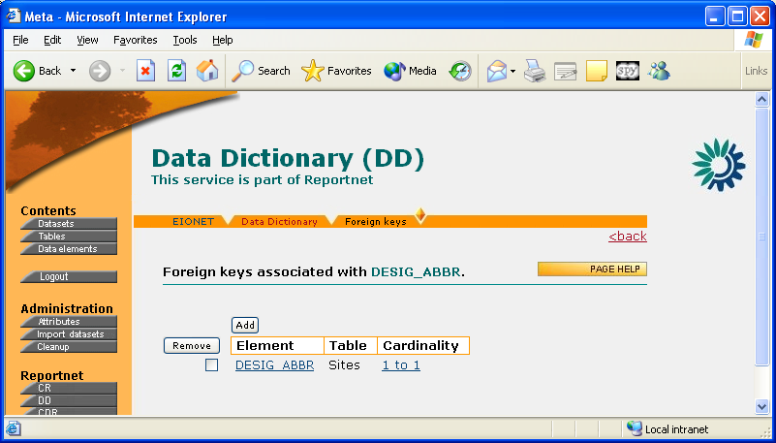Illustration 31: Foreign key relations of a non-common element

Adding images to data element definitions
You can illustrate a data element definition with images and it follows exactly the same rules as it was with table definitions (see same chapter for tables above).

Working with complex attributes
As it was mentioned above, edit views of dataset, table and element definitions have a link to viewing and editing the complex attributes of these definitions. The link opens a new popup window where you will see picture like on figure 32.
The defined complex attributes are displayed as a list of tables. Each table stands for one complex attribute and has the fields of the attribute as columns of the table. Each row in such a table stands for one value of the given complex attribute. The titles of these tables are the names of the complex attributes. In the left upper corner each table has a checkbox that you can use for marking attributes for deletion with Remove button. New attributes can be added by selecting the attribute from the select box in the page header and pressing Add new. This leads to the new attribute’s editing view (figure 33).
In the latter you can add new values/rows to the given complex attribute by specifying its field values and pressing Add.
It is also possible to copy previously inserted values. Just click the Copy button and this will open a popup form where you can select the desired row by clicking its first column. As a result, the form will close and the values of the selected row will be copied into the fields in attribute editing view. You can still manually change those fields before finally submitting them with a click to Add.
The values can also be taken from those harvested from outer sources (see chapter 5 about harvesting complex attributes). Each complex attribute can be linked with exactly one type of harvested complex attribute. The values of the latter will open if you click Get. You will see a popup window, where selecting a row will result in the row’s fields copied into your attribute editing view and the popup window closed. And then again by clicking Add you can submit them to the database.
Complex attribute values of non-common element and table definitions can be inherited from upper levels (upper levels of a non-common element are table and dataset, upper level of table is dataset). This depends on whether the complex attribute is defined to be inheritable or not (see chapter 5 about attribute definitions). If a value row is inherited, you won't see the checkbox in front of it!
NB! There are two types of inheritance. If inheritance is set to be over-writeable, then adding a new row using the inputs in figure 33 will lose all inherited rows. If inheritance is set to be not over-writeable then you can add new rows without losing any inherited rows.
Finally, to remove values/rows, use the checkboxes and Delete button.

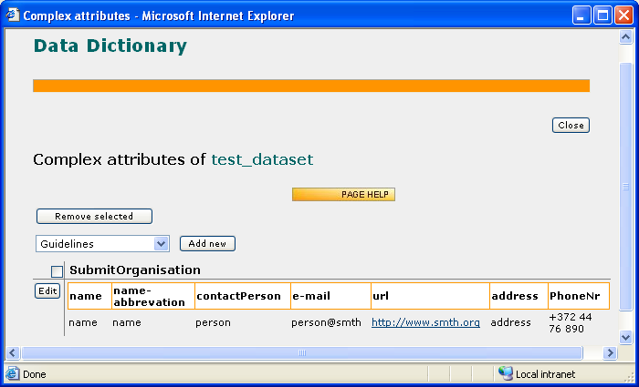Illustration 32: Working with complex attributes of a data definition
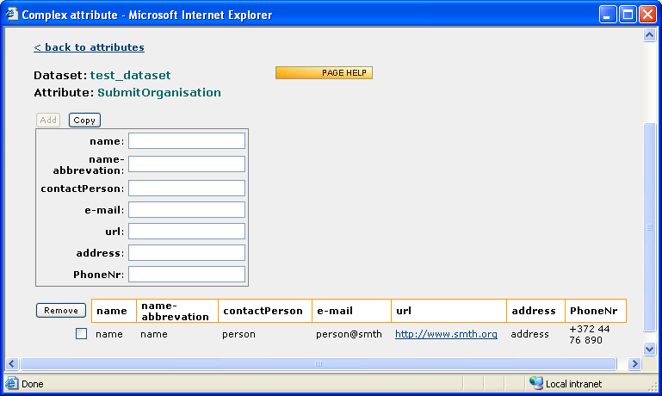Illustration 33: Complex attribute’s editing view

Administrators-only functionality
Administrators-only functionality is visible and accessible only for DD administrators after they have logged into the system. In the following sub-chapters it assumed that the reader is a DD administrator. Every sub-chapter represents one administrator-only function and is titled with the function’s name.

Defining attributes
Most of the attributes you see in dataset/table/element definitions are dynamic, i.e. they can be dynamically defined, i.e. addable/removable via DD web interface. Only the following attributes are static, i.e. not audible/removable via DD web interface:
- Identifier
The unique identifier of dataset/table/element definitions for internal purposes in the DD. Must contain no white space. Identifier is also used a tag name in XML-formatted data reporting. A table Identifier must be unique within its parent dataset. An element Identifier must be unique within its parent table
- Short name
A character string used to operationally identify dataset/table/element definitions in the DD, i.e. how users commonly refer to a table or an element or a dataset. A short name is not used as a unique identifier in DD.
- RegistrationStatus
Relevant only for datasets and common elements. See chapter about Registration status in the beginning.
- CheckInNo
Relevant only for datasets and common elements. See chapter about versioning in the beginning.
- Reference URL
Relevant for all definitions and displays The URL to use as a reference always pointing to the definition’s latest version.
- Public outputs
Relevant for datasets only. Enables to specify whether the so called create links for creating PDF and MS Excel files should be displayed for the given dataset and its tables.
- Type
Relevant for elements only and indicates the element type, i.e. whether it’s an element with fixed values or quantitative values.
- Is ROD parameter
Relevant for elements only and indicates if the given element is to be considered a parameter by ROD when the latter asks for the list of parameters by given reporting obligation ID.

Even though you cannot add/remove static attributes via DD web, you can nevertheless manage the online help that is displayed for these attributes. See more in chapter 5.2.

For dynamic attributes you have completely free hands in that you can define/remove new/existing attribute and manage existing attribute definitions. The moment you define an attribute, the moment it becomes visible in the dataset/table/element definition edit views, depending on which level you defined the attribute valid. The list of all dynamical attributes defined in DD (figure 34) is accessible by clicking Attributes in the left pane. It has 6 columns and an Add button for defining new attributes. Short name is clickable and leads to the attribute’s definition. Type indicates if the attribute is simple or complex (see chapter 1 for more). The rest of the columns indicate the definitions for which the attribute is valid by having a check-mark in the relevant column.
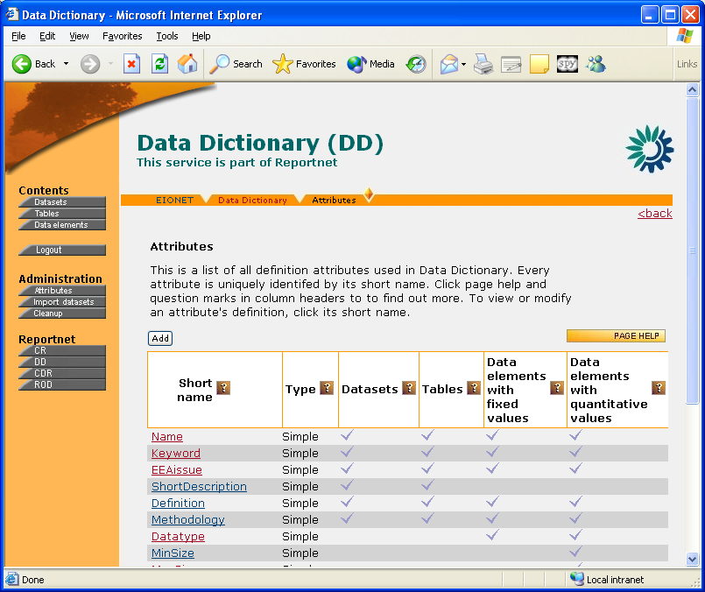Illustration 34: Attributes list

Defining simple attributes

Simple attribute definition view
Simple attribute definition view (figure 35) can be reached by clicking its Short name in the dynamical attributes list. It lists the attribute’s properties and a simple attribute can have the following properties:

- Short name (participates in the attribute’s unique identification)
A character string by which the users refer to an attribute in different data definition views. It should be compact while still reflecting the attribute’s concept.
- Name
The full name of the attribute. Usually not used in data definition views, but more wide-spread in oral communication and documents.
- Context (participates in the attribute’s unique identification)
Indicates if the attribute originates from ISO 11179 standard or DD business rules.
- Definition
The attribute’s full definition (i.e. description of its meaning).
- Obligation
Indicates if the attribute is mandatory in the definitions it is valid for (see the Display for attribute below about an attribute’s validity). Possible values are Mandatory, Optional, Conditional.
- Display type
Indicates if the attribute is displayed (in definitions of datasets/tables/elements) as a text box, text area, select box or an image.
- Fixed values
A simple attribute can have fixed values and if any have been specified, they are listed under this property in the attribute definition view. Their details can be found by clicking the property’s title.
- Display multiple
Indicates if this attribute can have multiple values at the same time. For example a Keyword could be 'environment', 'water' and 'lake' all at the same time.
- Inheritance
Tells if and how the attribute’s value(s) is(are) inheritable from higher levels (i.e. from dataset level to table level and from table to element level).
- Display order
Indicates the attribute’s position in the overall attributes list and in the definitions of datasets/tables/elements.
- Display for
Indicates the definitions where this attribute can be used. This can be any combination of the following values:
- dataset
- table
- elements with fixed values
- elements with quantitative values
- Display width
This property has effect only if the attribute’s Display type is text box. In such a case it indicates the width of the text box in terms of characters.
- Display height
This property has effect only if the attribute’s Display type is text area. In such a case it indicates the height of the text area in terms of rows.
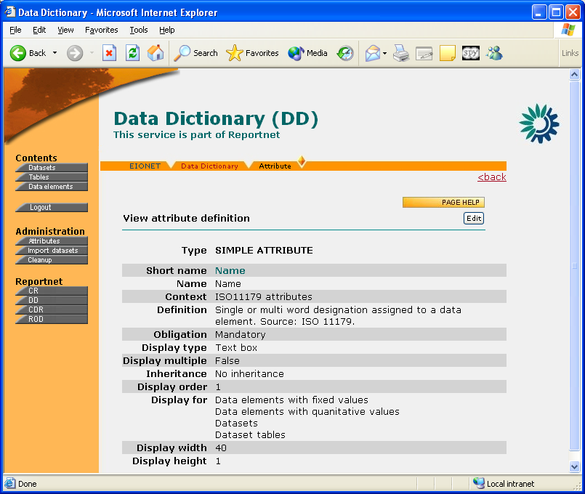Illustration 35: Simple attribute definition view

Simple attribute definition edit view
The view for editing a simple attribute’s definition can be reached by clicking the Edit button in the definition’s view page (see previous chapter). Compared to the latter, in edit page the attribute’s properties simply become editable, so no extra screenshot needed here. Some of the properties are mandatory to specify (marked with (M)) and some are optional (marked with (O)). The Save button submits your changes, Delete deletes the attribute, i.e. removes its existence. But be aware that only an attribute that is not used by any definition can be deleted!

Simple attribute definition adding view
The view for defining a new simple attribute can be reached by clicking Add in the dynamic attributes list described above. This will open a page where you will have to specify if you want to define a new simple or new complex attribute. By choosing to define a simple attribute, you will finally reach the view for defining a new simple attribute. It looks almost exactly like that for editing an existing simple attribute. The only difference is that here you must enter the attribute’s Short name. Keep in mind that it must be unique among all simple and complex attributes!
At the bottom of the page is the Add button, which creates the new attribute and leads you to its edit view. There you can continue editing the attribute’s properties and submit them by clicking Save. But you can also go straight to the attributes list to make sure your new attribute was created.

Defining complex attributes
A complex attribute definition view (figure 36) can be reached by clicking its Short name in the dynamical attributes list (see above). The definition view lists the attribute’s properties and a complex attribute can have the following properties:
- Short name (participates in the attribute’s unique identification)
A character string by which the users refer to an attribute in different data definition views. It should be compact while still reflecting the attribute’s concept.
- Name
The full name of the attribute. Usually not used in data definition views, but more wide-spread in oral communication and documents.
- Context (participates in the attribute’s unique identification)
Indicates if the attribute originates from ISO 11179 standard or DD business rules.
- Definition
The attribute’s full definition (i.e. description of its meaning).
- Inheritance
Tells if and how the attribute’s value(s) is(are) inheritable from higher levels (i.e. from dataset level to table level and from table to element level).
- Display order
Indicates the attribute’s position in the overall attributes list and in the definitions of datasets/tables/elements.
- Linked harvester
The value harvester associated with this complex attribute. More on this is available in the chapter about harvested complex attributes below.
- Fields
This is the most important property of a complex attribute. It is the list of definitions of the fields of the attribute. Each field has a Name and a Definition.
NB! Unlike simple attributes, complex ones do not have the Obligation property. They are almost always optional to specify for a definition. The only exception is the SubmitOrganisation attribute which is mandatory to specify for each and every definition in DD. Definitions of tables and non-common elements inherit the values of the SubmitOrganisation attribute of the parent dataset!
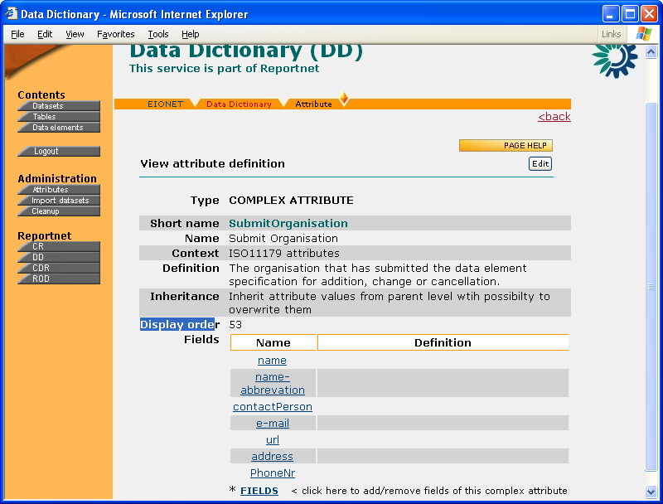Illustration 36: Complex attribute definition view

Complex attribute definition edit view
The view for editing a complex attribute’s definition can be reached by clicking the Edit button in the definition’s view page (see previous chapter). Compared to the latter, in edit page the attribute’s properties simply become editable, so no extra screenshot needed here. Some of the properties are mandatory to specify (marked with (M)) and some are optional (marked with (O)). The Save button submits your changes, Delete deletes the attribute, i.e. removes its existence. But be aware that only an attribute that is not used by any definition can be deleted!
For more on how to work with the Linked harvester property, see the chapter below about harvested complex attributes below!
More on how to work with definitions of the fields of a complex attribute is in a chapter below!

Complex attribute adding view
The view for defining a new complex attribute can be reached by clicking Add in the dynamic attributes list described above. This will open a page where you will have to specify if you want to define a new simple or new complex attribute. By choosing to define a complex attribute, you will finally reach the view for defining a new complex attribute. It looks almost exactly like that for editing an existing complex attribute. There are only two differences:
- here you must enter the attribute’s Short name. Keep in mind that it must be unique among all simple and complex attributes!
- here you cannot specify the attribute’s fields. You can do them via edit view later, but see a chapter below for more on how to do it exactly!
At the bottom of the adding page is the Add button, which creates the new attribute and leads you to its edit view. There you can continue editing the attribute’s properties, including the definitions of its fields. Or you can also go straight to the attributes list to make sure you’re new attribute was created.

Defining the fields of a complex attribute
The view for defining a complex attribute’s fields (figure 37) can be reached by clicking the [FIELDS < click here to add/remove fields of this complex attribute] link either in the attribute definition’s edit page or viewing page.
The view lists the already defined fields (if any) in 3 columns- the field’s Name, the field’s Definition and the field’s Priority. The latter specifies whether the field should be displayed in the definitions of datasets/tables/elements in order to save space on the page. A field with priority High is displayed, while the field with priority Low is not. In the detailed views of complex attributes of data definitions, however, all fields are always displayed.
You can remove the already defined fields by checking the boxes in front of those you want to remove and then clicking Remove selected.
You can also change the order in which they are displayed in the detailed views of complex attributes of data definitions. For that you have to click on the row of the field that you want to move (the click paints the row into light blue) and then use, use the classic moving icons on the right and finally click Save order to store the new order.
New fields can be defined by using the inputs and Add button above the list of already defined fields. There’s an input for the field’s Name and another one for the field’s Definition. Clicking Add creates a field with whatever you have entered and adds it to the bottom of the list of already defined fields.
A field’s Priority (as well as Definition) can be changed by clicking the field’s name in the list of defined fields. This will take you to the field’s details where you can change the Priority and the Definition and submit your changes by clicking Save. Clicking Delete will remove the field from existence.
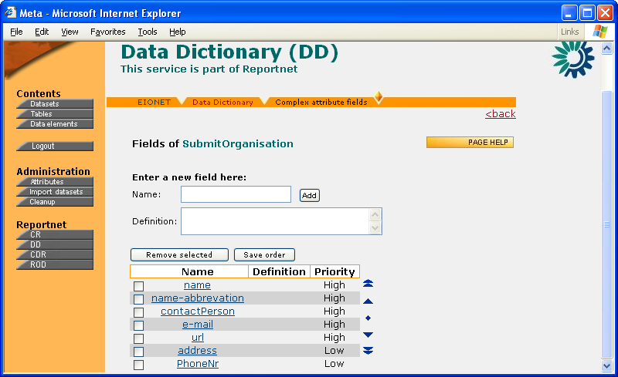Illustration 37: Defining the fields of a complex attribute

Deleting an attribute definition
As it was mentioned above, an attribute’s definition and usage can be removed from existence by clicking the Delete button in the attribute’s edit view, be it a simple or a complex attribute. So you must delete them one-by-one.
But be aware that only an attribute that is not used by any definition can be deleted! And usually they aren’t defined, unless they are also used. So it is a rare occasion that you must delete an attribute’s definition.

Attribute’s inheritance
Attribute inheritance means that, if defined so, an attribute of a definition of a table can inherit its value(s) from its datasets. Similarly, if defined so, an attribute of a definition of a non-common element can inherit its value(s) from its table and/or dataset. And the definition can be done in the edit views of attribute definition as it was described in chapters above. You must have noticed that in these views you can define an attribute to be not inheritable at all (the default) or you can choose between two types of inheritance for the attribute:
- Inherit attribute values from parent level with possibility to add new values.
This means that the attribute inherits its value(s) from parent level(s), but in addition to those it can also have some values of that level itself. In other words, such an attribute of the definition of a non-common element inherits values from its table and dataset, but in addition to those it could also have a couple of values of its own.
For example if Keyword is an attribute of such inheritance and Keyword ‘Marine’ has been defined at dataset level, keyword ‘Ocean’ has been defined at table level and keyword ‘Sea’ has been defined at element level, then:
the valid value for the dataset is ‘Marine’
the valid values for the table are ‘Marine’ and ‘Ocean’
the valid values for the element are ‘Marine’, ‘Ocean’ and ‘Sea’
- Inherit attribute values from parent level with possibility to overwrite them.
This means that the attribute inherits its value(s) from parent level(s). But the moment a value is added on that very level only, it overrides the value(s) inherited from upper levels and they are lost. For example the moment a new non-common element is defined, an attribute with such type of inheritance automatically acquires the values of the same attribute of its table and dataset. But the moment a new value is added, the latter are lost.

Harvested complex attributes
Imagine that you have specified one and the same Submitting Organisation (including for example its address and phone number) for many data elements, tables and datasets. Now all of the sudden the organisation’s phone number changes. You’d have to go through all the places where this organization has been specified and change the Phone Number field. This is very tedious. To help you out, DD enables to link selected complex attributes to values harvested from outside world. That outside world would most likely be some kind of LDAP directory. This way, whenever something changes in the latter, it will automatically also reflect in your complex attribute in DD. And you won’t have to enter the changes manually in all the different places.
DD can have several harvesters running in the background for you.
You can link a complex attribute to a certain harvester by using the ‘Linked harvester’ field in complex attribute definition edit view. See figure 38 below. It lists the currently available harvesters. Choosing ‘—no link –‘ means you don’t want the attribute to be linked to any harvesters (the default behaviour). Choosing a certain harvester means that whenever specifying this complex attribute for data elements, tables or datasets, you can choose its values from the ones harvested by the linked harvester. Later they will automatically change whenever something changes in the harvester source.
Once you’ve linked your complex attribute to a certain harvester and pressed Save, two things will happen:
- A Harvest button will appear next to the ‘Linked harvester’ field. By pressing this you can perform a harvesting session of the linked harvester. But be aware that depending on the network connection speed and the amount of harvested values this operation might take minutes. You should do this only when the linked harvester in the background has for some reason stopped working and you have an emergency situation!
- Your complex attribute’s fields will become “linkable” with the corresponding fields in the linked harvester. This is needed, because the fields of the linked harvester are not always the same as those of the complex attribute to which you linked it. So you can (and must) define mappings between the fields of your complex attribute and the linked harvester. This can be done by opening the list of your complex attribute fields (see above), going to each field’s editing view (figure 39) by clicking on its name and then choosing a linked harvester field from ‘Linked harvester field’ select box. You must link only those fields that the DD business logic defines as mandatory.
Currently DD has only one complex attribute harvester, which in the list of harvesters provided by ‘Linked harvester’ field is titled ‘Organisations harvester’. It harvests organisation data from EEA’s LDAP directory.
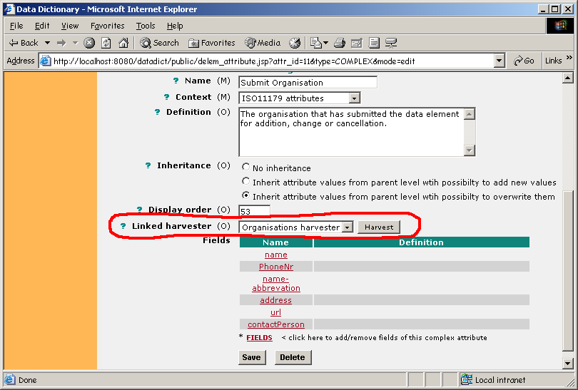Illustration 38: Linking a complex attribute with a harvester
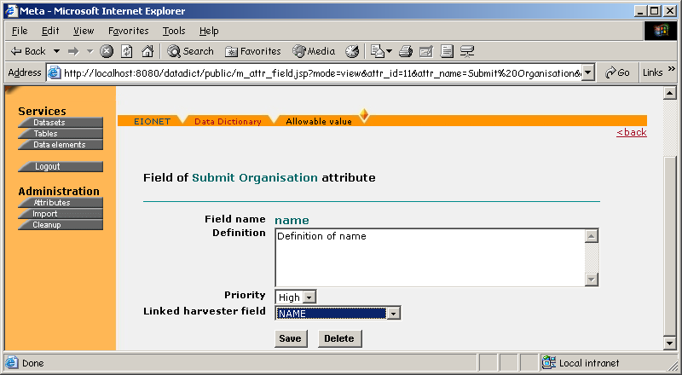Illustration 39: Linking complex attribute fields with linked harvester fields

The cleanup function
The Cleanup function enables to clean the database from all kinds of leftovers that might result from exceptional situations. It must be used with great caution, because one might accidentally delete some important data.
The function is reachable by clicking the grey ’Cleanup’ button in the left pane of DD UI.
Naturally, it is visible and accessible only when the user has rights to perform the Cleanup function.
The Cleanup function page looks like on figure 40:

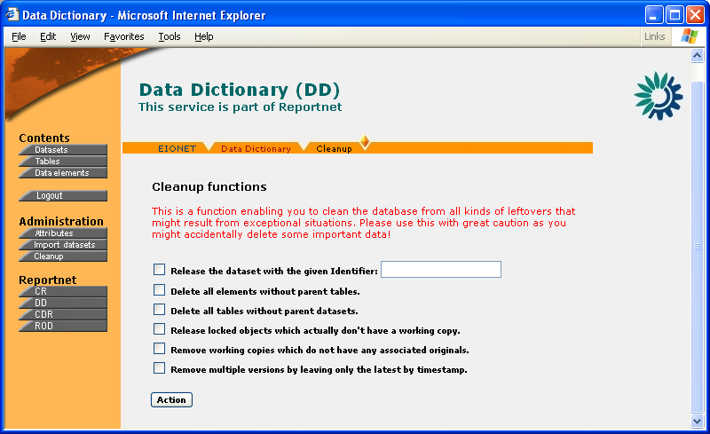Illustration 40: The cleanup function
You can select the following operations:
- Release the dataset with the given Identifier
This is to be used when a dataset is locked, but it is actually not checked out and nor does it have any tables or elements checked out.
- Delete all elements without parent tables
This deletes all elements that have a link to a table, which doesn’t actually exist. This might happen if a table gets deleted, but its links to elements do not.
- Delete all tables without parent datasets
This deletes all tables that have a link to a dataset, which doesn’t actually exist. This might happen if a dataset gets deleted, but its links to tables do not.
- Release locked objects which actually don't have a working copy
This one deletes all such elements, tables and datasets that are checked out, but don’t have a working copy.
- Remove working copies which do not have any associated originals
This one is sort of opposite to the previous one. It deletes all working copies of elements, tables and datasets that don’t have the original that was actually checked out.
- Remove multiple versions by leaving only the latest by timestamp
If a logically unique element, table or dataset has several instances of one and the same version (for example there are 3 instances of version 1 of element X) then this function leaves only the instance latest by creation time. By version we mean the CheckInNo.

Selected operations will be executed by pressing ’Action’.

NB! Normally the Cleanup user does not actually have to understand the essence of the above functions. If selecting all functions, DD takes care of performing them in the safest order. This should result in the total cleanup of all currently identified abnormalities

Import tool
Import tool is an MS Access-based utility enabling to define datasets, tables and data elements (but no attributes and contexts!) in a flat table and then afterwards populate the definitions into DD database, using XML as an intermediate format. The reason for such a tool is simply because when entering a large amount of definitions, a flat table might be handier than the web-based user interface with its many different views and clicking back and forth in between them. To find out more about the import tool and it’s purpose please read the detailed design document. The following chapters will give an overview about the functionality of import tool and some guidance about how to use it.

Table structure
There are 4 main tables, one link table and one lookup table in MS Access import tool:
- DATASET – stores dataset’s auto generated id, identifier, short name and attributes
- DS_TABLE – stores table’s auto generated id, link to dataset, table identifier, short name and attributes
- DATAELEM – stores data element’s auto generated id, identifier, short name, type and attributes
- FIXED_VALUE – stores fixed value’s auto generated id, link to data element, value and attributes
- TBL2ELEM – link table for linking data elements and tables
- DATAELEM_TYPE – lookup table for storing data element type’s codes and descriptions.
The main tables have attributes, which are taken from Data Dictionary and converted into tabular formats. One attribute is one column in the table. The attribute names in the tables should be the same as in Data Dictionary e.g. there is a column Definition in DATASET table and there is also Definition attribute in Data Dictionary for dataset.
For complex attributes, it is a little bit different as complex attributes may have several fields and several values. We have used some kind of simplification in the import tool. For example, if there is an attribute Guidelines with fields Url and Description, then in Access tables the corresponding fields would be: Guidelines_Url_1 and Guidelines_Description_1. If there should be two guideline attributes, then the number should be incremented: Guidelines_Url_2 and Guidelines_Description_2.
Next chapters will give an overview about the table’s fields in the import tool.

DATASET table
DATASET table has auto-generated id DATASET_ID. This field is required for linking tables and datasets and the user cannot change this value. The following table gives the brief descriptions of the fields in the DATASET table.
Field name | Description | Data type | Field size
SHORT_NAME | This is the technical/abbreviated name of the dataset | Text | 20
Version |  | Text | 20
Name | Single or multi word designation assigned to a data element. Source: ISO 11179 | Text | 255
Identifier | The unique identifier used in DD and described above in the chapter of concepts. | Text | 50
ShortDescription | Brief text about the content | Text | 255
Definition | Statement that expresses the essential nature of a dataset and permits its differentiation from all other datasets. Source: ISO 11179 | Text | 1000
DescriptionOfUse | Brief description of common/ anticipated use | Text | 1000
Theme | Predefined list of themes | Text
Sub-theme | Predefined list of sub-themes. This describes where in the hierarchical thematic structure the dataset belongs/is placed | Text
Keywords | One or more significant words used for retrieval of data elements. Source: ISO 11179. | Text | 1000
SynNames_name_1 | Other common name | Text | 255
EEAissue_name_1 | Predefined list of issues as used by EEA | Text | 255
Methodology | Brief description of methodology | Text | 1000
PlannedUpdFreq | Planned updating frequency of the dataset | Text | 255
References | References on more information about the definition of dataset sub elements of reference | Text | 1000
RegistrationAuthority_name_1 | institution in charge of the specification | Text | 255
Guidelines_url_1 | Guideline link to document | Text | 255
Guidelines_description_1 | Guideline’s description | Text | 1000

DS_TABLE table
DS_TABLE has two system fields - auto generated id DATASET_ID and link to the dataset DATASET_ID. The first field is required for linking tables and data elements and user cannot change this value. DATASET_ID is actually displayed for the user as a select box with datasets’ short names. The following table gives brief descriptions of the other fields in DS_TABLE table.

Field name | Description | Data type | Field size
SHORT_NAME | This is the technical/abbreviated name of the dataset | Text | 40
Name | Single or multi word designation assigned to a data element. Source: ISO 11179 | Text | 255
Definition | Statement that expresses the essential nature of a dataset and permits its differentiation from all other datasets. Source: ISO 11179 | Text | 1000
Methodology | Brief description of methodology | Text | 1000

DATAELEM table
DATAELEM table has auto-generated id DATAELEM_ID. This field is required for linking data elements to tables and fixed values. Its type is a field with values specified in DATAELEM_TYPE table. The following table gives brief descriptions about the other fields in DATAELEM table.
Field name | Description | Data type | Field size
SHORT_NAME | This is the technical/abbreviated name of the data element | Text | 50
Name | Single or multi word designation assigned to a data element. Source: ISO 11179 | Text | 255
SynNames_name_1 | Other common name | Text | 100
Definition | Statement that expresses the essential nature of a data element and permits its differentiation from all other data elements. Source: ISO 11179 | Text | 1000
Datatype | A set of distinct values for representing the data element value. Source: ISO 11179. | Text | 50
MinValue | Data element minimum value | Integer
MaxValue | Data element maximum value | Integer
DecimalPrecision | Number of digits after comma | Integer
MinSize | The minimum number of storage units to represent the data element value. Source: ISO 11179. | Text | 50
MaxSize | The maximum number of storage units to represent the data element value. Source: ISO 11179. | Text | 50
Methodology | Brief description of methodology | Text | 1000
Identifier | A language independent unique identifier of a data element within a Registration authority. Source: ISO 11179. | Text | 50
Version | Version of the element definition | Text | 25
ShortDescription | Brief text about the content of the element | Text | 100
Unit | Unit of which data element value has been measured | Text | 50
RegStatus | A designation of the position in the registration life cycle of a data element. Source: ISO 11179. | Text | 50
References | References on more information about the definition of dataset sub-elements of reference | Text | 255
Keywords | One or more significant words used for retrieval of data elements. Source: ISO 11179. | Text | 1000
EEAissue_name_1 | Predefined list of issues as used by EEA – 1 | Text | 255
Guidelines_url_1 | Guideline link to document | Text | 255
Guidelines_description_1 | Guideline’s description | Text | 1000
RegistrationAuthority_name_1 | Institution in charge of the specification | Text | 255

FIXED_VALUE table
FIXED_VALUE table has auto-generated id FIXED_VALUE_ID. Users cannot change this field, because that is system field. DATAELEM_ID is a link to data element. Users can see the data element name and not the real value there. The following table gives brief descriptions about the other fields in FIXED_VALUE table.

Field name | Description | Data type | Field size
VALUE | This is the technical/abbreviated name of the data element | Text | 255
DEFINITION | The definition of the fixed value | Text | 1000
SHORTDESCRIPTION | Short description of the fixed value | Text | 255

Copying a large amount of values into FIXED_VALUE table …
… is a typical problem when you have your values ready somewhere in another table, possibly in another program too. Suppose you want to copy and paste values for an element called EUNIS_hab. Follow the next procedure:
You go to the fixed values table of EUNIS_hab element. It opens when you press 'Data elements' on the main form and go to the row of EUNIS_hab. In the left-most column you click the plus sign. That opens the fixed values of EUNIS_hab.
Now you go to the program and table where you have EUNIS_hab values ready. We assume you got the columns of values and definitions right next to each other (values left, definitions right). You select both columns and do Ctrl+C..
Now you go back to EUNIS_hab fixed values that you opened in Import tool. In the new row (where the AutoNumber is waiting) you select Value and Definition cells. You do this by clicking in the Value cell. No you point the mouse over the blinking cursor. The mouse pointer should look like the medical cross now. You hold down shift and press the left mouse button. Value becomes selected. Keep the shift down and left-click in the Definition. The latter becomes selected as well. Now press Ctrl+V and the values you copied above will be pasted into EUNIS_hab fixed values table.
That should be it.

TBL2ELEM table
This is the link table and ordinary users shouldn’t know much about this table. The most important fields are TABLE_ID and DATAELEM_ID. These ones tell in which the data element belongs to. The other fields are not in use currently.

Insert data
In this chapter we look step by step, how to insert the data definitions about one dataset into the import tool. All the definitions should be inserted straight to the tables or queries. This way of implementation decreases checking possibilities of inserted data definitions to minimum. But on the other hand it’s very easy to copy and paste the data definitions into tables by selecting multiple rows. Tables have easy sorting possibilities by clicking on the top of the column with right button and selecting ascending or descending. To delete the data, select the row or rows by clicking on the left most column and pressing Delete button.

Main form
The version since 0.9 has special ‘Main’ form (figure 41), where it is easier to reach the data tables. The form is opened automatically at start up and it has 5 buttons. Click on Datasets, Tables or Data elements button will open the corresponding table, where it’s possible to insert data definitions. ‘Make xml’ button will open the form, where it’s possible to generate xml file with inserteddefinitions. And the button in the downside right corner will close the application.
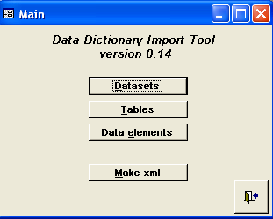Illustration 41: Main form

Add a new dataset definition
The first thing is to define dataset. As mentioned before, all the data about datasets is stored in DATASET table. Select Tables from the left-hand pane and table click on that table. New dataset can be inserted into the last row of the table. DATASET table is described on figure 42.
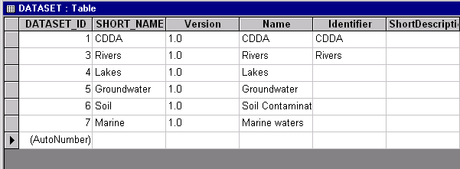Illustration 42: DATASET table

Add a new table definition
For adding a new table definition into a dataset, please open the dataset table’s table by double-clicking on DS_TABLE. The first thing to do is to select the dataset, where does the new table belong. And then add all the attributes as needed. Pay attention to the + signs in the left most column. These ones open a data elements table inside DS_TABLE and it’s possible to see right away which data elements are belonging into the selected table.
DS_TABLE is described on figure 43.
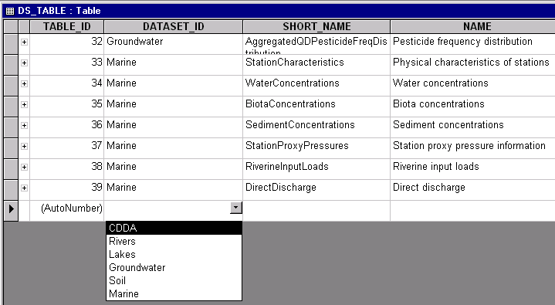Illustration 43: DS_TABLE table

Add a new data element definition and fixed values
Data element definition is related to a table and fixed values. That is the reason, why it is not convenient to insert the data into DATAELEM table, but special query is created for that. Please select Queries on the left-hand panel and open q_DATAELEM query. DATAELEM_ID is auto generated and user should not pay attention to that field. TABLE_ID is select box, where user can select the table name, where the data element belongs. And other fields are exactly the same as described in DATAELEM table above. The left most column contains the + sign. It opens the fixed values subsheet by clicking on that. Be sure that TYPE = CH1, before you will insert the fixed values.
Q_DATAELEM query is described on figure 44.

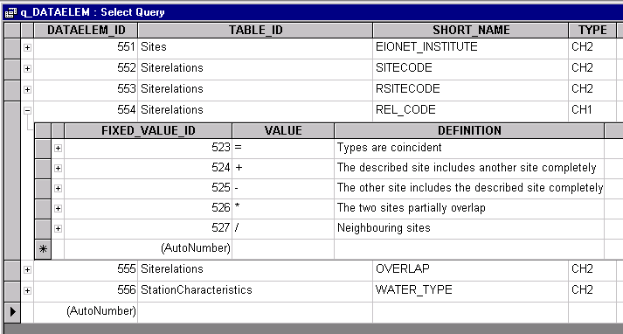Illustration 44: q_DATAELEM query

Generate XML file
It is possible to generate two types of XML files:
- ‘All datasets’ option …
… is for generating an XML file with all the data inserted into the database. It means that all the datasets and their components (tables, datasets, dataelements and fixed values) are involved in the xml file.
- ‘Code list’ option …
… is for generating an XML file that will contain only fixed values (code list) of a selected data element and nothing else. In other words this the option to use if you only want to Import the fixed values of a selected data element and no other information from Import tool.
Once you select the ‘Code list’ option, you will be provided with a drop-down list of elements form where you select the element whose values you want to import. Make sure you select an element! The list has only elements of fixed values type. For making the selection easier the data elements are displayed together with dataset and table name.
Once you have chosen the type of XML generation you want, you must write down the location and file name, where the file should be generated (e.g. C:\Temp\importtables.xml) and press Generate button. The generating process may take some time, if there are many rows in the database tables. After finishing the process, a message box appears and lets the user know about the results.
Close button closes the form. For changing the default filename displayed on the form, please click on the ‘Change default file’ button. A new table is opened, where the filename is stored. Read more about that in the next chapter.
XML generation form is described on figure 45.
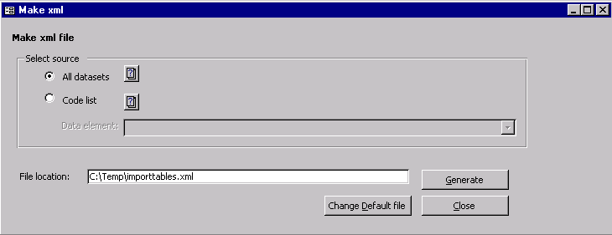Illustration 45: Make xml form
Once the XML has been generated, the user uploads it into DD, using the corresponding form in DD user interface and the importing code transports it all into the DD database. The import web page has been described above.

Setup data
SETUP_DATA table stores the default file location and filename, where to generate XML file. If the file destination is the same every time, then it’s handy to use setup data table. If you store the filename and location info into this table, then next time the name will appear on the xml form.
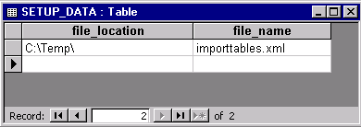Illustration 46: Setup data

Importing the data into Data Dictionary
The generated XML file you can import into DD by pressing the Import button on the left pane (it will become visible only after you have logged in). As a result, you will be presented with a form (figure 47) where you can upload the generated XML file. You can either locate the file on your local file system or type the URL from where the DD should download this file. In both cases you submit your data definitions by pressing the Import.
Currently it is possible to import only the definitions of whole datasets and not tables or data elements separately. If there is already a dataset with the same name, then it should be deleted first or the new one should be renamed.
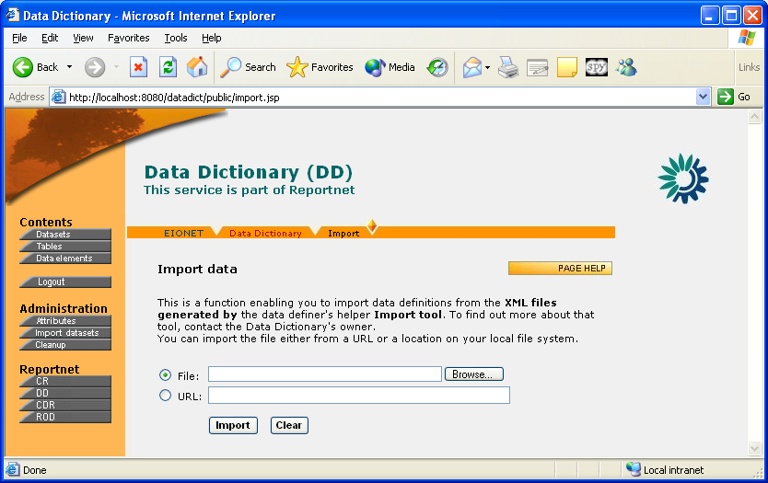Illustration 47: Data import view in DD user interface

Import results
The result of the import is a log with messages as plain text. The page starts with errors and warnings. Most commonly the errors are caused from duplicate entries or database connections. And warning messages tells that some of the mandatory attributes do not have values. Please remember that this is just a warning and the values can be inserted later on the web pages. Please find the possible messages and their descriptions from the following table. Besides these error messages, there might be XML parsing messages.
A link at the top of the page enables to save the listed import results into a PDF file.
Message | Description
Not authorized to store data! | User has not logged in or the session is expired. Please log in again.
Could not find mandatory attribute (Identifier) value from specified xml for dataset - Lakes! | Mandatory attribute field was empty in XML file. This is just a warning. The value can be inserted later on web forms.
Dataset import failed! Could not store dataset into database - CDDA  java.sql.SQLException: A dataset with this identifier and version already exists! | There is already a dataset called CDDA. This means that all the tables and data elements within CDDA dataset have not imported either. Please delete the old dataset or rename the new one.
Dataset id was not found for table: Designations | The message is caused by previous error. The table could not be imported since the corresponding dataset were not imported
Dataset import failed! Could not store data element into database - YEAR  java.sql.SQLException: identifier or namespace not specified! | The message is caused by previous errors. The data element could not be imported since the corresponding dataset and table were not imported.
Data element id was not found for fixed value Annual | The message is caused by previous error. The fixed value could not be imported since the corresponding data element was not imported.
Data element id was not found for complex attribute | The message is caused by previous error. The complex attribute could not be imported since the corresponding data element was not imported.

The second part of the page is information about the import results in numbers. It tells how many datasets, tables and data elements were found from XML file and how many of them were successfully imported.
The third part lets the user know, if there were any unknown attributes in the XML file. If there are any, then these should be defined in the Data Dictionary by the user. These are not automatically updated.

Importing fixed values only
As hinted for many times above, you can use Import tool for importing only the fixed values of a selected data element and nothing else. But since it’s a much needed feature, it deserves a closer look. Step-by-step, the procedure is as follows:
- If you have a large amount of fixed values for some data element ready in another application in some kind of table, you can copy and paste them into the tool’s FIXED_VALUE table as described in the FIXED_VALUE table chapter above.
- Once you have the values of your target element ready and entered into FIXED_VALUE table, you can generate them into an XML file by choosing the ‘Code list’ option in the tool’s ‘Generate XML’ form (see above chapters about the main form and XML generation form).
- As a result of step 2, you will have an XML formatted file containing the fixed values of your target element. Now you go to the element’s fixed values list in DD User Interface (see chapters for fixed values lists). In there you should see a button titled ‘Import’. Click the button and DD will guide to the import page. That’s where you select the file generated in step 2 and press Import.
Since you came from a specific data element’s fixed values view, DD knows that it’s a fixed values import and it knows the element you want to import for.

Limitations
NB! There are some important limitations to the Import tool that you should know:
- The tool does not have a link to DD database. This means that its model is not automatically self-updating when the model in the DD database has changed. The most concrete example can be given on the basis of attributes. In Import tool they are represented as columns in the tables worked with. In other words the attribute set in Import tool has been hardcoded. While in the DD database attributes are defined in rows, rather than in columns. This finally means that whenever a new attribute is added to the DD database, or an existing one is changed or deleted, it will not automatically reflect in Import tool and the changes must be done by hand. This sounds like quite a drawback, but luckily the changes do not concern the code. Only a new column has to be added/removed to/from a selected table.
- Whenever the user induces an XML generation, all the contents of tool's database at that moment will be generated into XML.
This means that if the user has defined several different datasets, but wants to import only one of them into DD, he/she has to create a separate instance of the tool for that dataset and use that instance for entering and importing the definition of the desired dataset.
So it is highly recommended that before you start entering any definitions into the Import tool, make it clear if you want to actually import only some of them. And if so, create a separate tool instance for those.
While this might sound rather primitive, creating a separate instance of Import tool is luckily rather easy. Because Import tool is just another MS Access file (.mdb) and all you have to do is to make a copy of it.

